**Analog Electronics Practical:**

**Exp – 1 :**

**Aim**: Study of V-I characteristics of a P-N junction diode under Forward bias and reverse bias.

**Theory:**

**Structure ->**

The diode is a device formed from a junction of n-type and p-type semiconductor material. The lead connected to the p-type material is called the anode and the lead connected to the n-type material is the cathode. In general, the cathode of a diode is marked by a solid line on the diode.

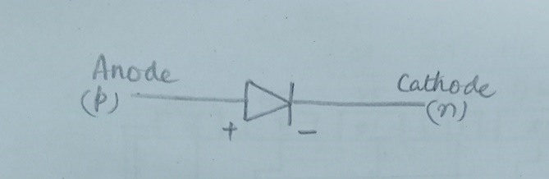

**Function of a P-N junction diode in Forward Bias ->**

The positive terminal of battery is connected to the P side(anode) and the negative terminal of battery is connected to the N side(cathode) of a diode, the holes in the p-type region and the electrons in the n-type region are pushed toward the junction and start to neutralize the depletion zone, reducing its width. The positive potential applied to the p-type material repels the holes, while the negative potential applied to the n-type material repels the electrons. The change in potential between the p side and the n side decreases or switches sign. With increasing forward-bias voltage, the depletion zone eventually becomes thin enough that the zone's electric field cannot counteract charge carrier motion across the p–n junction, which as a consequence reduces electrical resistance. The electrons that cross the p–n junction into the p-type material (or holes that cross into the n-type material) will diffuse into the nearby neutral region. The amount of minority diffusion in the near-neutral zones determines the amount of current that may flow through the diode.

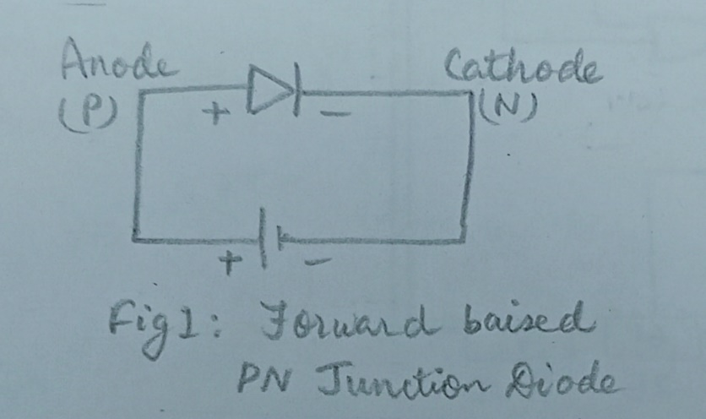

**Function of a P-N junction diode in Reverse Bias** ->The positive terminal of battery is connected to the N side(cathode) and the negative terminal of battery is connected to the P side(anode) of a diode. Therefore, very little current will flow until the diode breaks down.

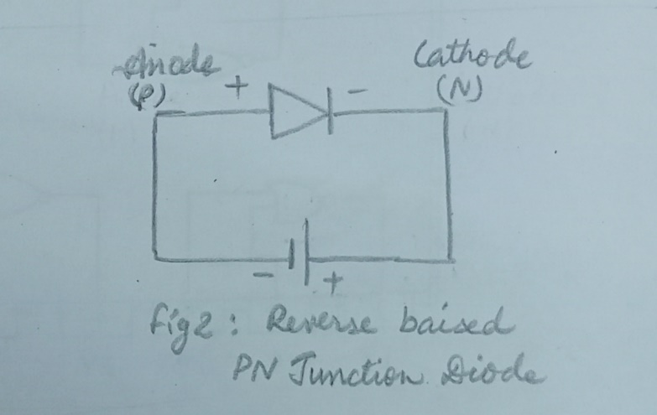

**Diode Equation** ->  
In the forward-biased and reversed-biased regions, the current (If), and the voltage (Vf), of a semiconductor diode are related by the diode equation.

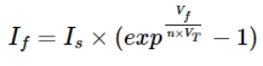

where,

Is is reverse saturation current or leakage current,

If is current through the diode (forward current),

Vf is potential difference across the diode terminals (forward voltage)

Vt is thermal voltage, given by

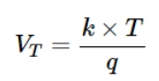

**Experimental Data:**

Diode: 1N4001

Knee Voltage: 0.6 V

Resistance: 100 ohms

**Forward Bias Characteristics:**

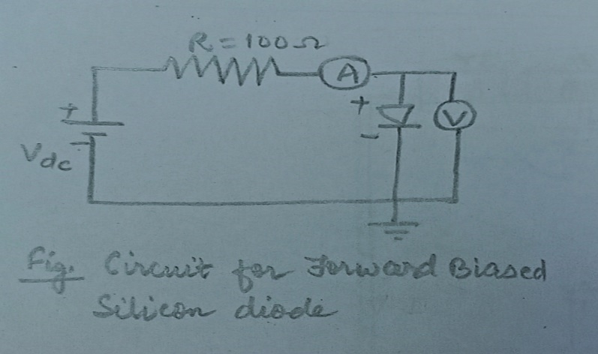

**Table: Observation table for the Forward Biased Silicon diode:**

|  |  |  |
| --- | --- | --- |
| **Serial No.** | **Forward Voltage(Volt)** | **Forward Current(mAmp)** |
| 1 | 0 | 0 |
| 2 | 0.589 | 0.997 |
| 3 | 0.593 | 1.99 |
| 4 | 0.599 | 3.99 |
| 5 | 0.607 | 7.98 |
| 6 | 0.615 | 13.0 |
| 7 | 0.618 | 15.0 |
| 8 | 0.622 | 18.9 |
| 9 | 0.626 | 22.9 |
| 10 | 0.628 | 24.9 |
| 11 | 0.632 | 29.9 |
| 12 | 0.635 | 33.9 |
| 13 | 0.638 | 39.9 |
| 14 | 0.641 | 43.9 |

**Graphs:**

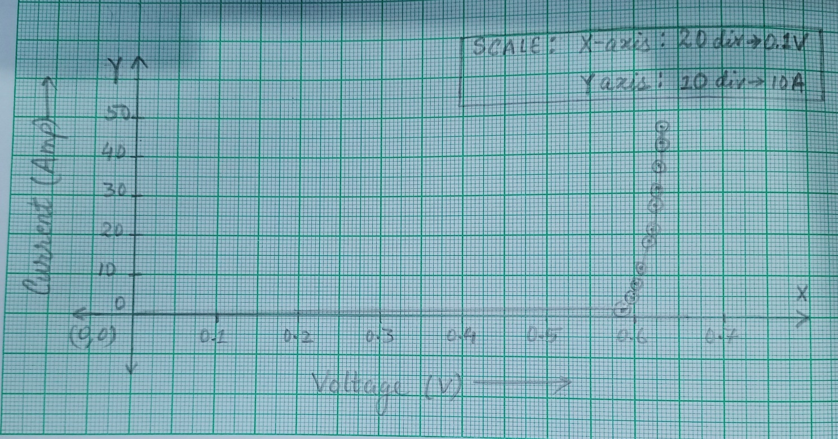

**Screenshot Attached:**

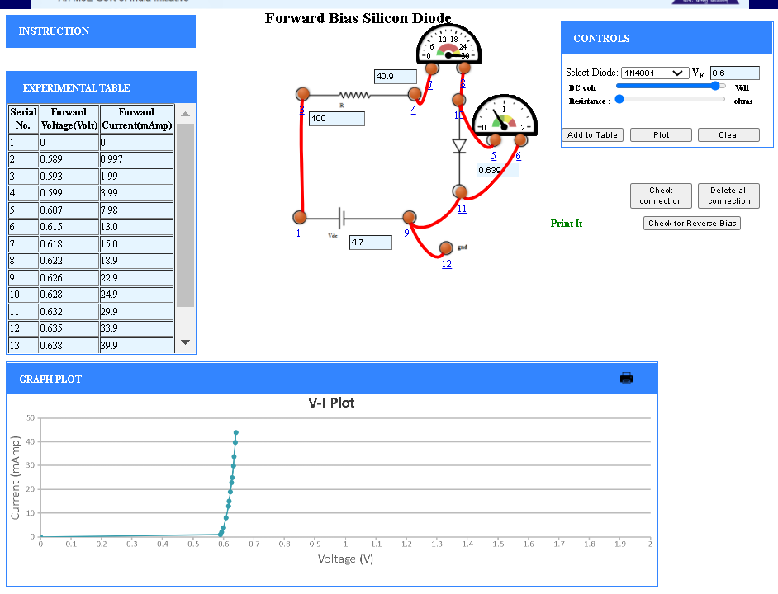

**Reverse Baised characteristics:**

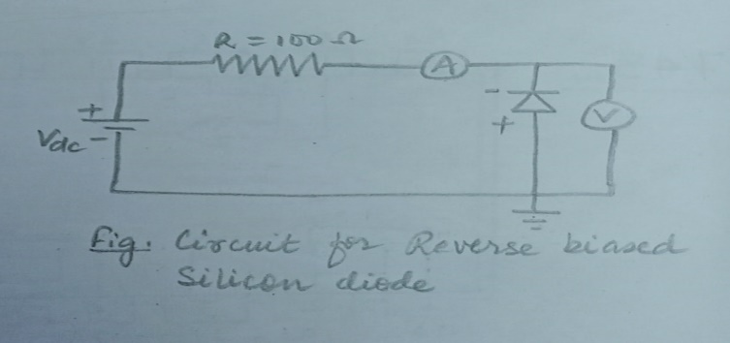

**Table: Observation table for the Reverse Biased Silicon diode:**

|  |  |  |
| --- | --- | --- |
| **Serial No.** | **Reverse Voltage(Volt)** | **Reverse Current(μAmp)** |
| 1 | 0.170 | 0.100 |
| 2 | 1.32 | 0.100 |
| 3 | 4.46 | 0.100 |
| 4 | 6.72 | 0.100 |
| 5 | 9.41 | 0.100 |
| 6 | 11.5 | 0.100 |
| 7 | 14.4 | 0.100 |
| 8 | 17.5 | 0.100 |
| 9 | 21.2 | 0.100 |
| 10 | 24.2 | 0.100 |
| 11 | 27.0 | 0.100 |
| 12 | 29.4 | 0.100 |
| 13 | 30.2 | 75.125 |
| 14 | 30.3 | 75.37499999999999 |
| 15 | 30.4 | 75.5 |

**Graph:**

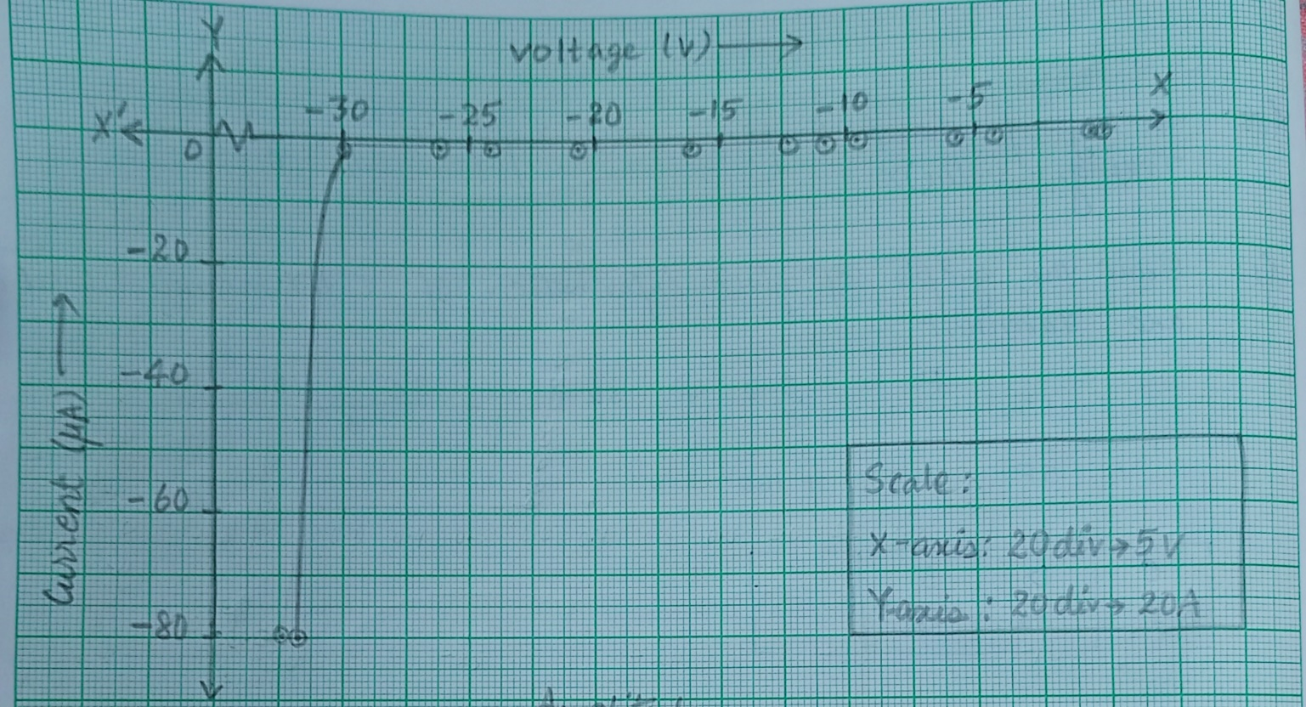

**Screenshot Attached:**

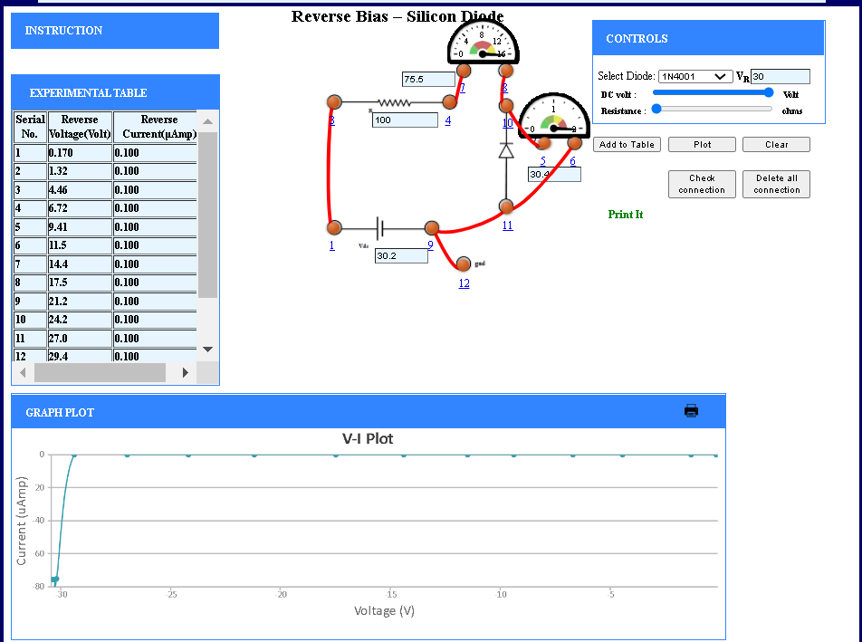

**Conclusion:** We observed from the V-I characteristics graph of forward biased Si diode, that there the graph is almost flat, with small linear rise until the knee voltage is achieved and after that there is a steep rise in current flowing through the diode. From V-I characteristics of Reversed biased Si diode, we observed that there is almost no change in the voltage until the breakdown region of the diode is achieved and after that there is a sudden increase in the current flowing through the diode.

**Experiment – 2, 3 & 4:**

**AIM:**

Study on half wave and full wave rectifier & Capacitive Rectification. Determination of ripple factor.

**THEORY:**

**Half Wave Rectifier-**

A half wave rectifier is defined as a type of rectifier that only allows one half-cycle of an AC voltage waveform to pass, blocking the other half-cycle. On the positive cycle the diode is forward biased and on the negative cycle the diode is reverse biased. By using a diode we have converted an AC source into a pulsating DC source

The Ripple Factor in a half wave rectifier can be calculated with the following equations:

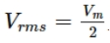 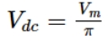

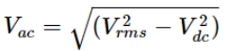

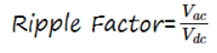

Where,

Vdc = Output DC Voltage

Vm = Peak Voltage

**Full Wave Rectifier-**

A full-wave rectifier converts the whole of the input waveform to one of constant polarity (positive or negative) at its output and A full-wave rectifier converts the whole of the input waveform to one of constant polarity (positive or negative) at its output.

To calculate the Ripple Factor:

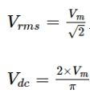 

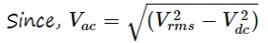

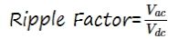

Where,

Vdc = Output DC Voltage

Vm = Peak Voltage

**EXPERIMENTAL DATA:**

Frequency = 1000 Hz

RL = 200 Ω

**Half Wave Rectifier-**

**Circuit Diagram**-

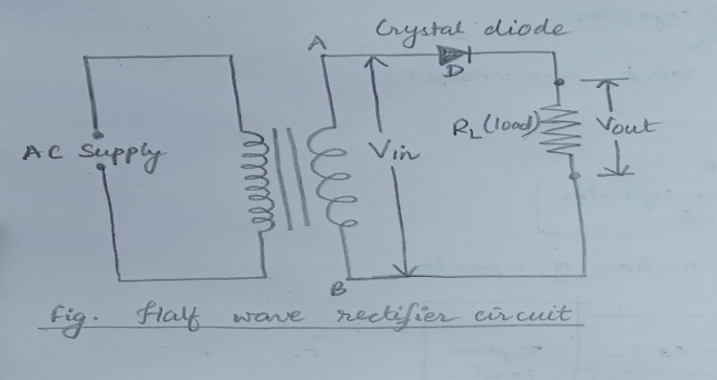

**Calculation for Ripple factor-**

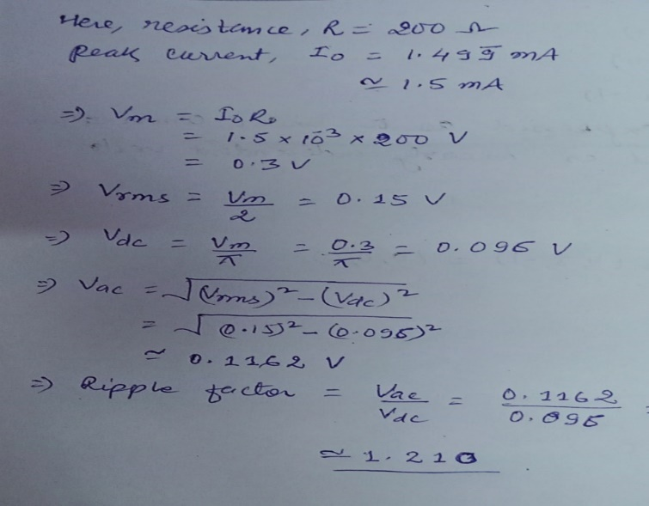

**Half Wave Rectifier with Capacitive Rectification Circuit Diagram-**

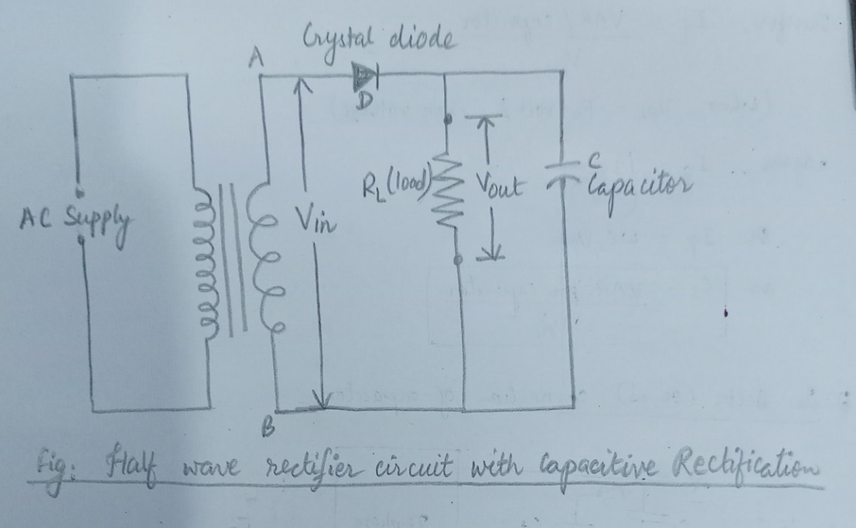

**Waveform for Sine Wave, Half Wave Rectified, Half Wave and Capacitive Rectified**:

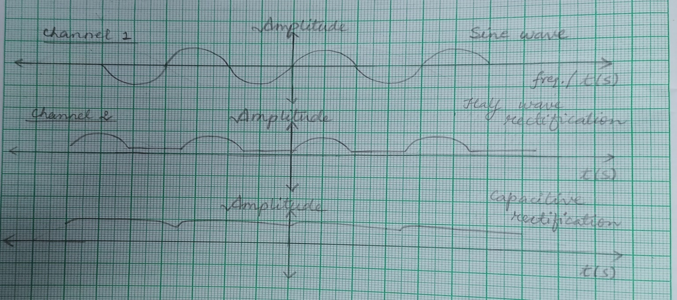

**Full Wave Rectifier-**

**Circuit Diagram-**

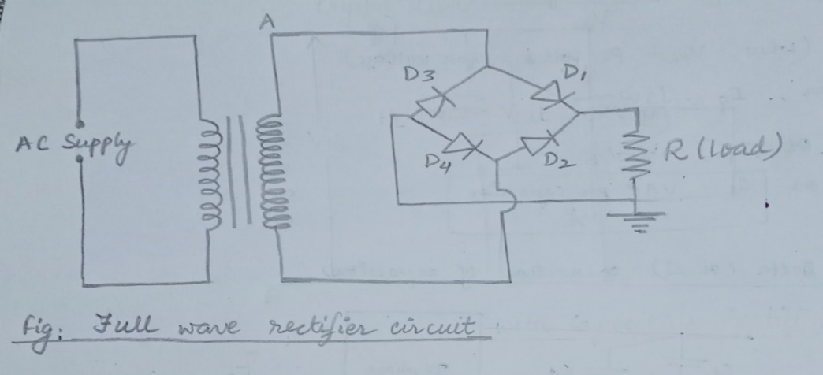

**Calculation:**

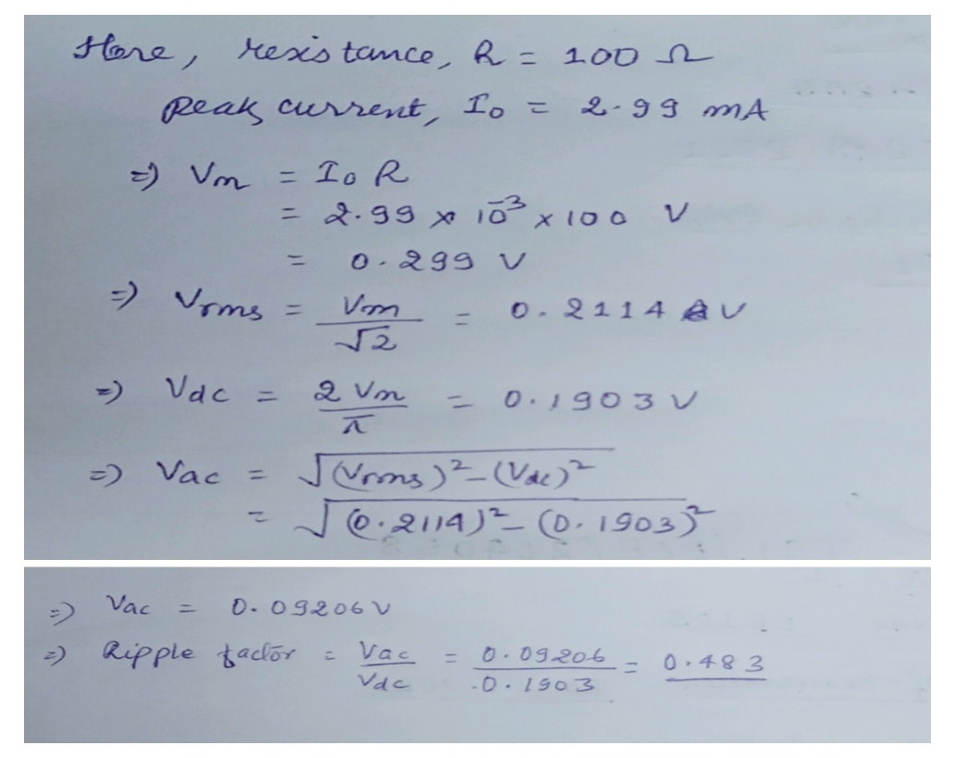

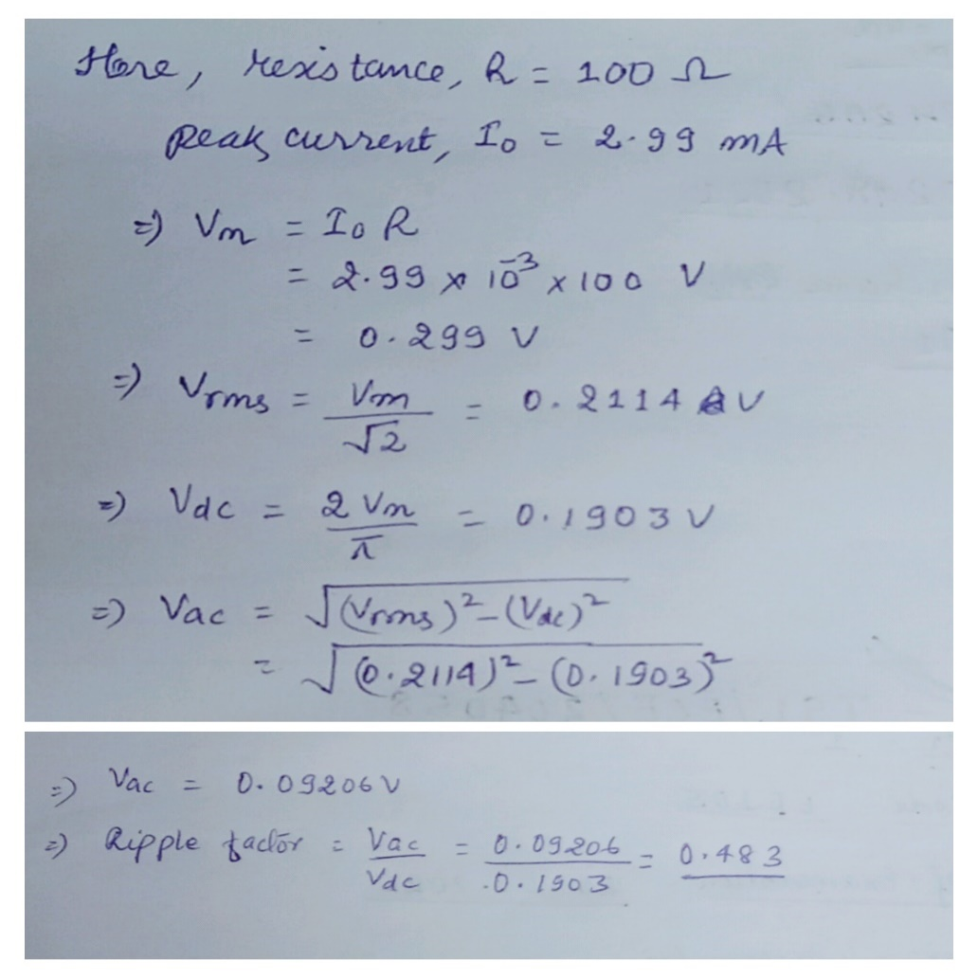

**Full Wave Rectifier with Capacitive Rectification Circuit Diagram**-

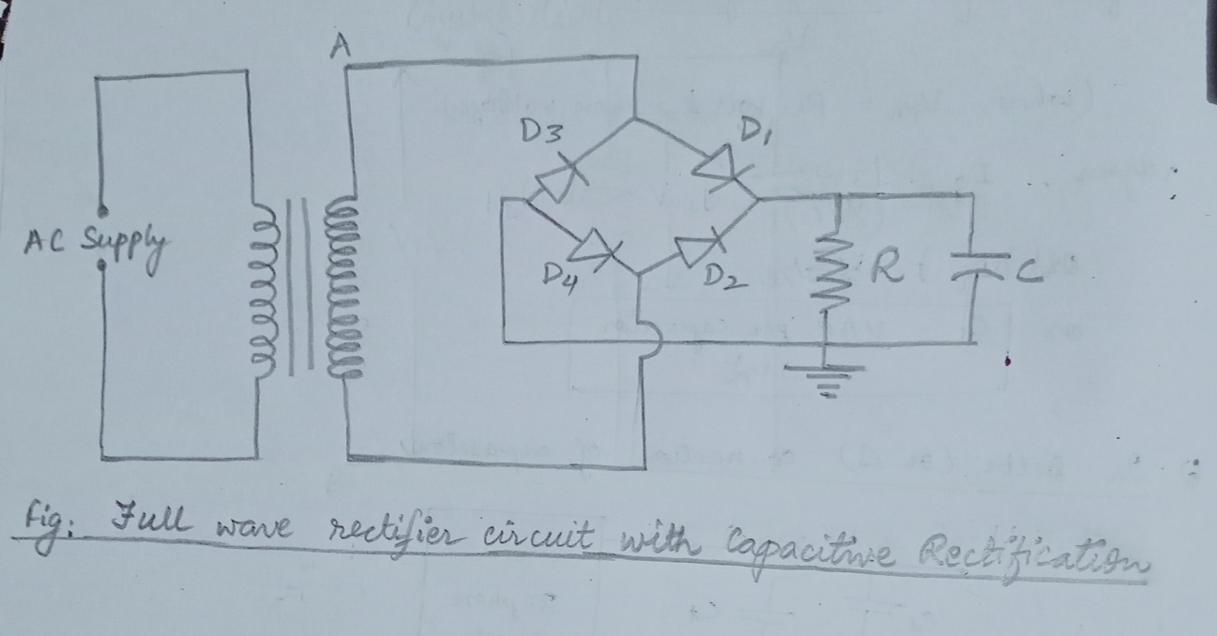

**Waveform for Sine Wave, Full Wave Rectified, Full Wave and Capacitive Rectified**:

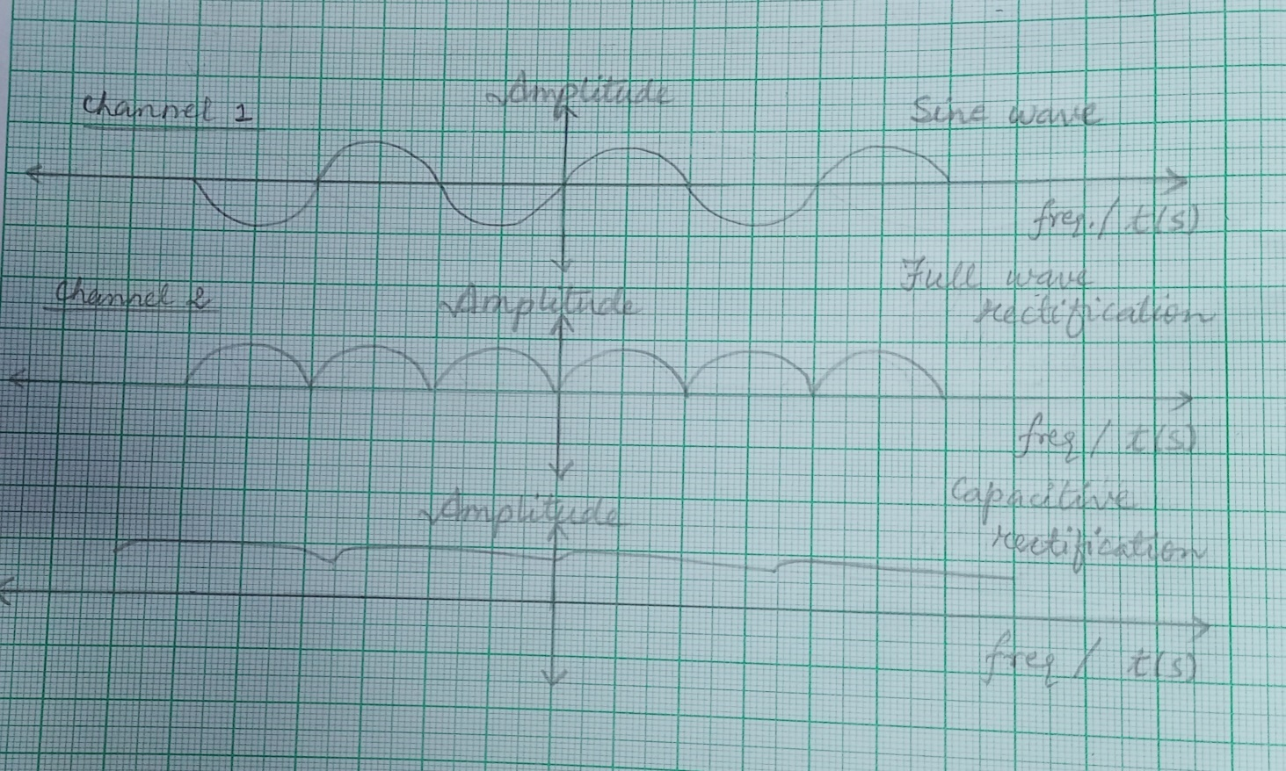

**Screenshots Attached:**

1. **Half wave rectifier:**

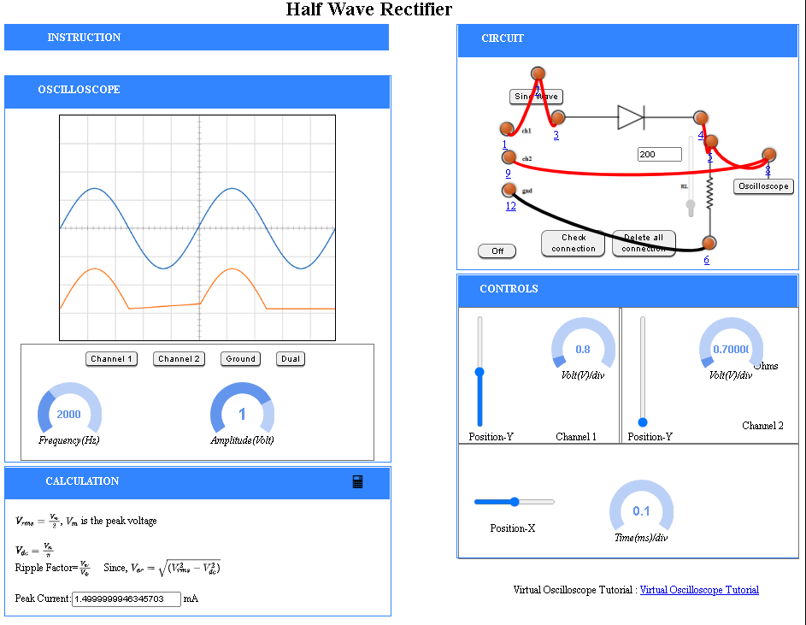

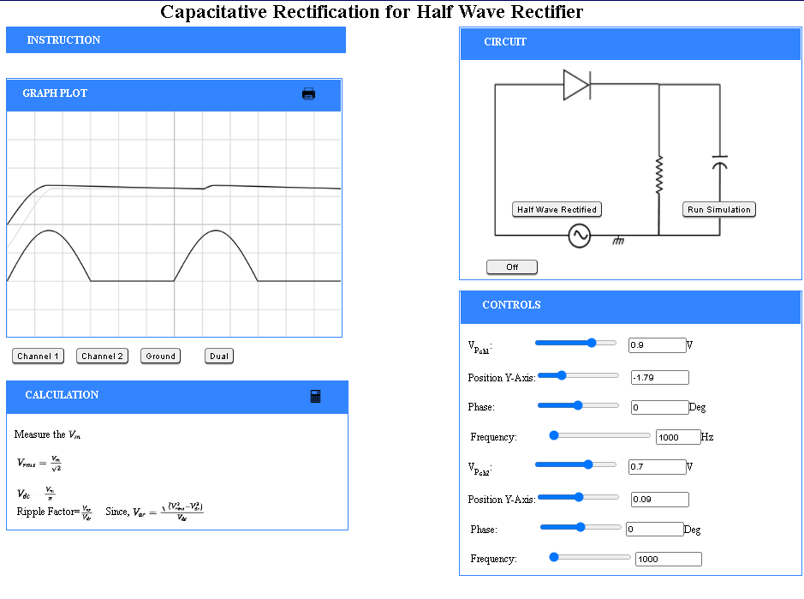

1. **Full Wave Rectifier:**

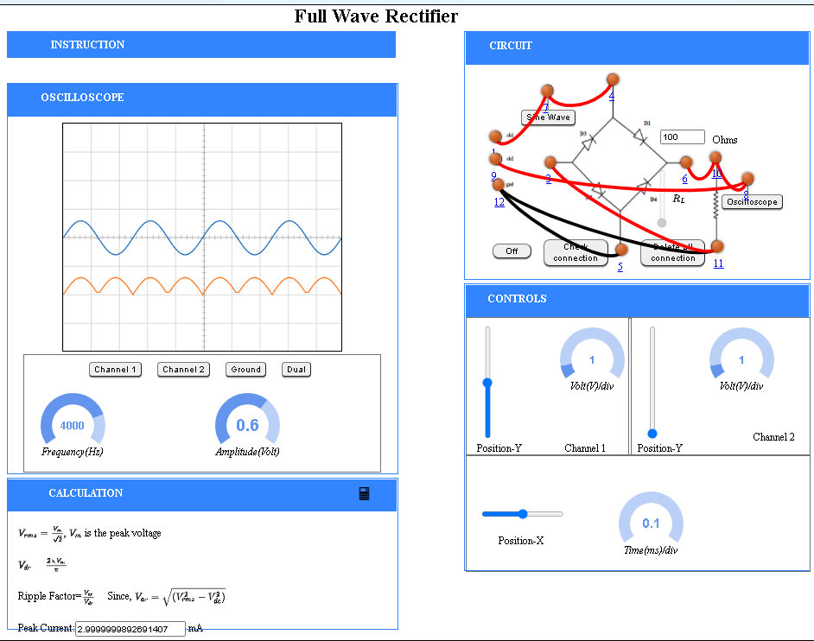

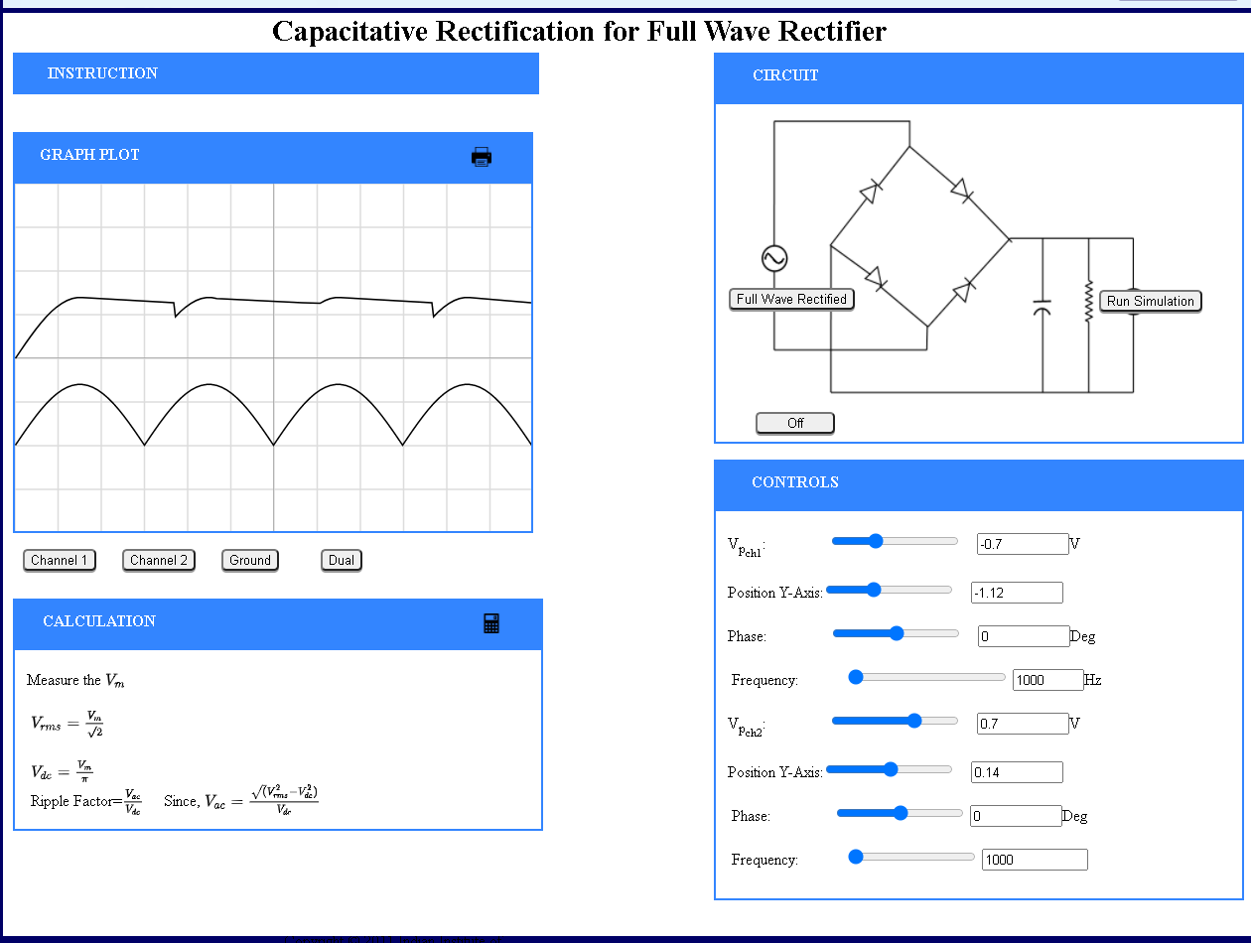

**CONCLUSION**:

The Ripple factor for Full Wave Rectified circuit is found to be 0.48 & for the Half Wave Rectified circuit it is found to be 1.21. The waveforms obtained on an oscilloscope are drawn on the graph. This shows that capacitive rectification the A.C. is converted to D.C. with good results.

**Experiment – 5 :**

**AIM:**

Study the V-I Characteristics of Zener Diode under Reverse Bias and Forward Bias.

**THEORY**:

A Zener Diode is a special kind of diode which permits current to flow in the forward direction as normal, but will also allow it to flow in the reverse direction when the voltage is above the breakdown voltage or Zener voltage. Zener diodes are designed so that their breakdown voltage is much lower. In the reverse bias direction, there is practically no reverse current flow until the breakdown voltage is reached. When this occurs, there is a sharp increase in reverse current. Varying amount of reverse current can pass through the diode without damaging it. The breakdown voltage or zener voltage (VZ) across the diode remains relatively constant.

A voltage regulator is an electronic circuit that provides a stable DC voltage independent of the load current, temperature and AC line voltage variations. A Zener diode of break down voltage VZ is reverse connected to an input voltage source VI across a load resistance RL and a series resistor RS. The voltage across the Zener will remain steady at its break down voltage VZ for all the values of zener current IZ as long as the current remains in the break down region. Hence a regulated DC output voltage VO=VZ is obtained across RL whenever the input voltage remains within a minimum and maximum voltage.

There are 2 types of regulations:

1. **Line Regulation**: In this type of regulation, series resistance and load resistance are fixed, only input voltage is changing. Output voltage remains the same as long as the input voltage is maintained above a minimum value.

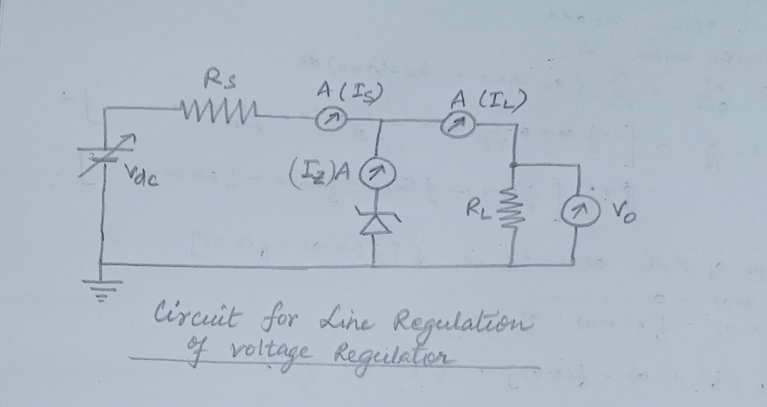

1. **Load Regulation**: In this type of regulation, input voltage is fixed and the load resistance is varying. Output volt remains same, as long as the load resistance is maintained above a minimum value.

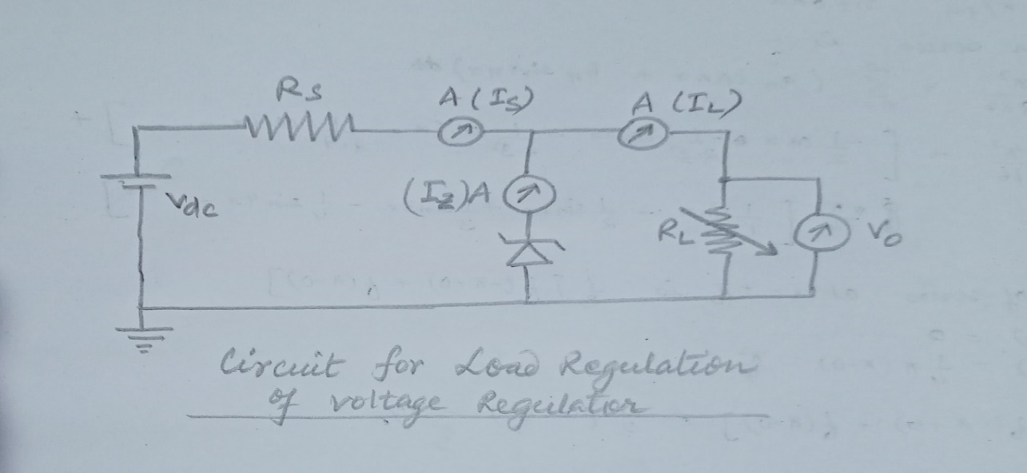

**Experimental Data:**

**Line Regulation –**

Zener Voltage(VZ):V   
Series Resistance(RS):KΩ  
Load Resistance (RL):KΩ

|  |  |  |  |  |  |
| --- | --- | --- | --- | --- | --- |
| **Serial No.** | **Unregulated supply voltage(VS) V** | **Load Current(IL) mAmp** | **Zener Current(IZ) mAmp** | **Regulated Output Voltage(VO) V** | **% Voltage Regulation** |
| 1 | 5.2 | 5.09 | 0 | 5.2 | 100 |
| 2 | 5.4 | 5.09 | 0 | 5.4 | 100 |
| 3 | 5.6 | 5.09 | 0 | 5.6 | 100 |
| 4 | 5.8 | 5.09 | -3.091 | 5.60 | 100 |
| 5 | 7.6 | 5.09 | 14.909 | 5.60 | 71.4 |
| 6 | 10.4 | 5.09 | 42.909 | 5.60 | 50.0 |
| 7 | 13 | 5.09 | 68.909 | 5.60 | 38.5 |
| 8 | 15.2 | 5.09 | 90.909 | 5.60 | 33.3 |
| 9 | 19 | 5.09 | 128.909 | 5.60 | 26.3 |

**Line Regulation Graph –**

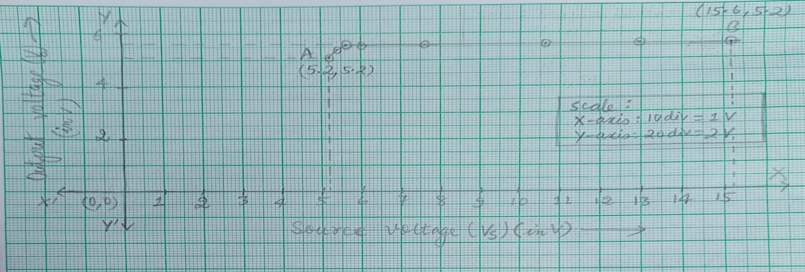

**CALCULATION OF LINE REGULATION:**

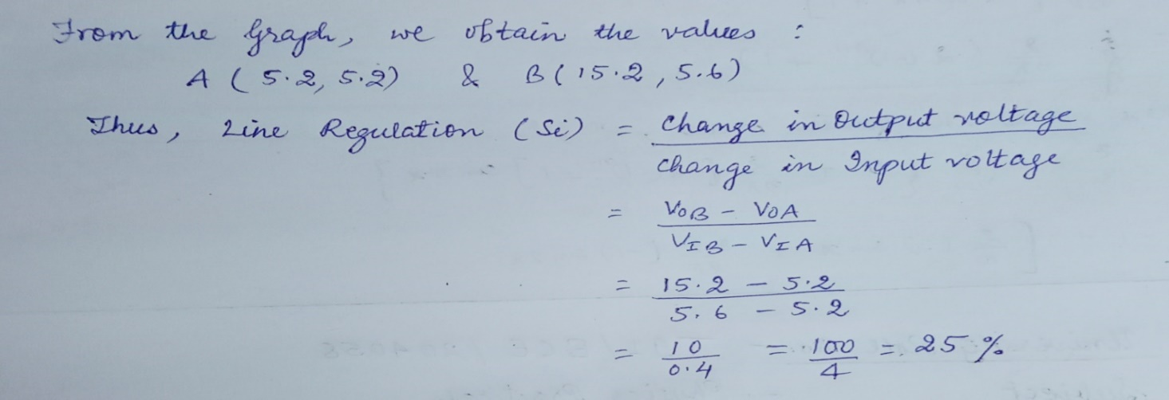

**Screenshot attached:**

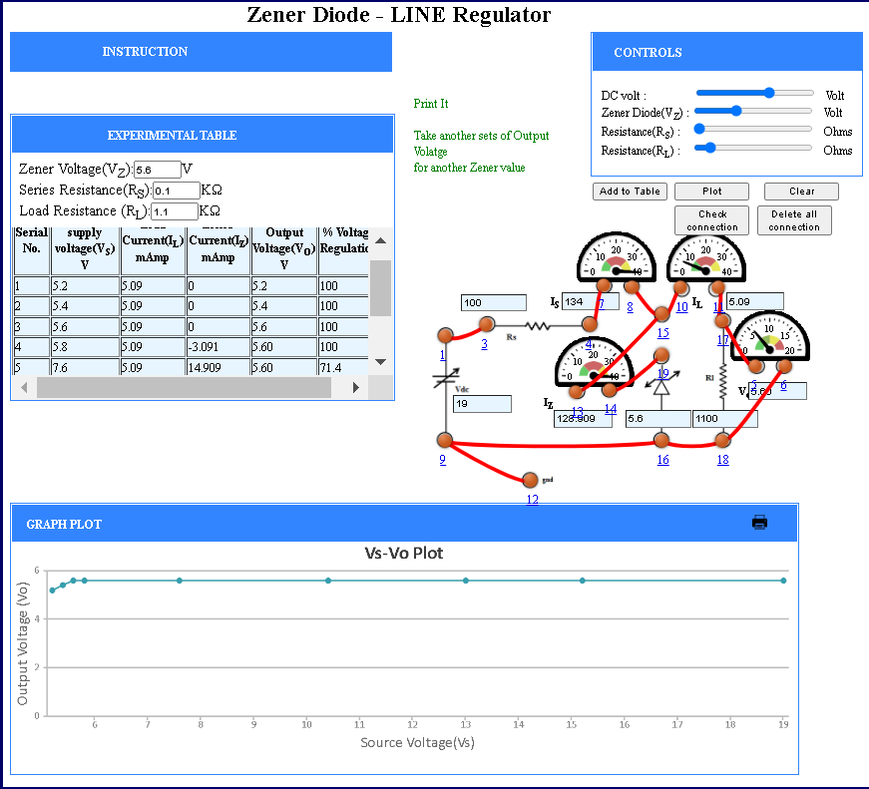

**Load Regulation:**

DC Voltage (VDC):V Zener Voltage (VZ):V  
  
Series Resistance (RS):KΩ

|  |  |  |  |  |  |
| --- | --- | --- | --- | --- | --- |
| **Serial No.** | **Load Resistance(RL) Ohm** | **Load Current(IL) mAmp** | **Zener Current(IZ) mAmp** | **Regulated Output Voltage(VO) V** | **% Voltage Regulation** |
| 1 | 150 | 34.0 | 0 | 8 | 40.0 |
| 2 | 152 | 33.6 | 0 | 8 | 39.7 |
| 3 | 172 | 29.7 | 0 | 8 | 36.8 |
| 4 | 197 | 25.9 | 3.11 | 5.10 | 33.7 |
| 5 | 223 | 22.9 | 6.13 | 5.10 | 31.0 |
| 6 | 254 | 20.1 | 8.92 | 5.10 | 28.2 |
| 7 | 280 | 18.2 | 10.8 | 5.10 | 26.3 |
| 8 | 324 | 15.7 | 13.3 | 5.10 | 23.6 |
| 9 | 624 | 8.17 | 20.8 | 5.10 | 13.8 |
| 10 | 827 | 6.17 | 22.8 | 5.10 | 10.8 |
| 11 | 948 | 5.38 | 23.6 | 5.10 | 9.54 |
| 12 | 1063 | 4.80 | 24.2 | 5.10 | 8.60 |
| 13 | 1235 | 4.13 | 24.9 | 5.10 | 7.49 |

**Graph:**

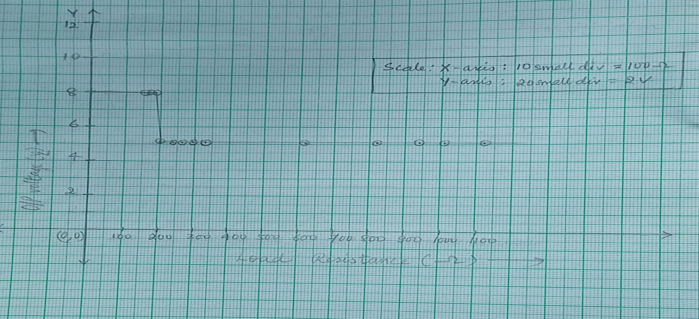

**Calculation :**

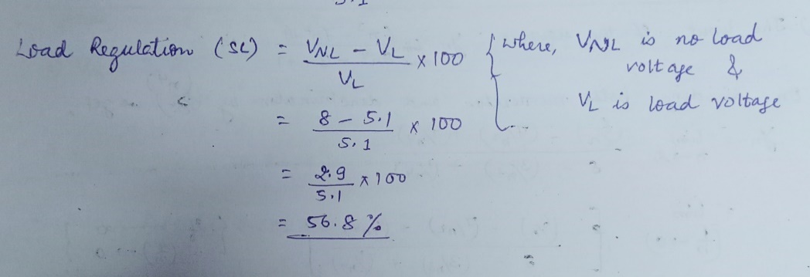

**Screenshots Attached:**

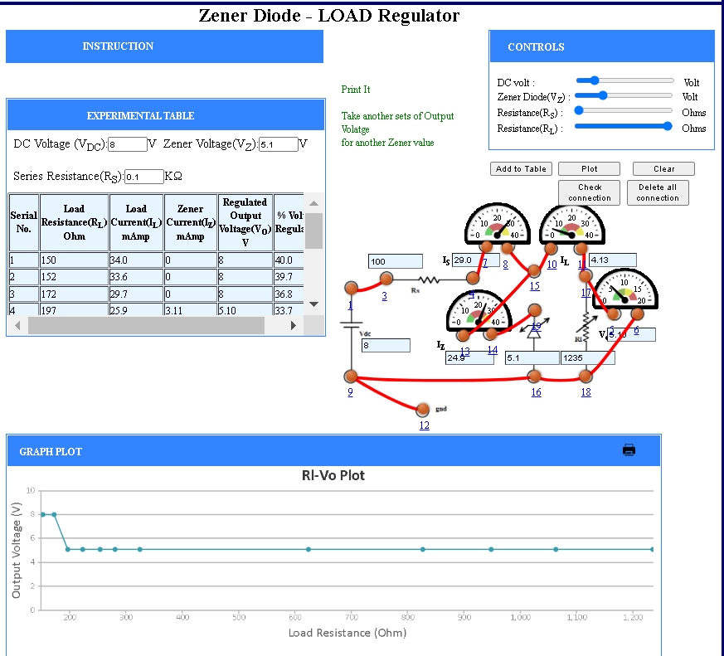

**Conclusion:** We understood the Zener diode characteristics for Line Regulation & Load Regulation.

The V-I characteristics shows that the unregulated input voltage is regulated to the Zener voltage after the input exceeds the Zener voltage value.

**Experiment – 6:**

**AIM:** Study the Input and Output Characteristics Curve for BJT Common Base (CE) mode.

**THEORY**: A Common Emitter Bipolar Junction Transistor, BJT, is a single piece of silicon with two back-to-back P-N junctions. BJTs can be made either as PNP or as NPN. They have three regions and three terminals, Emitter, Base, and Collector represented by E, B, and C respectively. The direction of the arrow indicates the direction of the current in the emitter when the transistor is conducting normally.

**N-P-N**  **P-N-P**

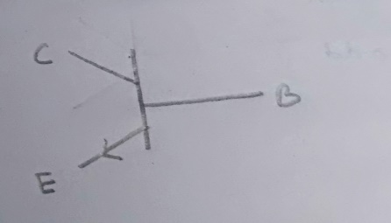 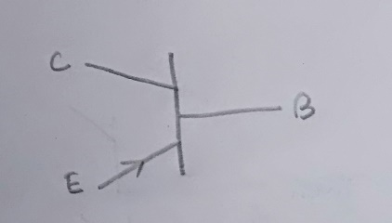

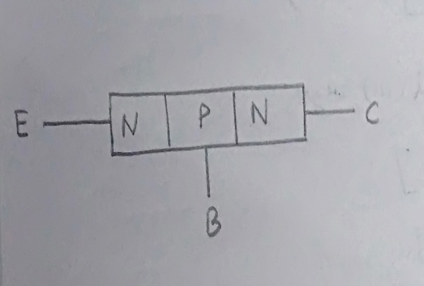 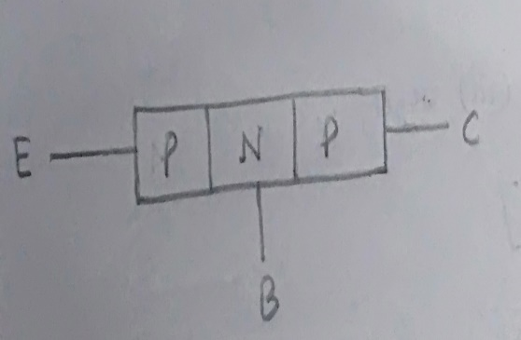

Emitter is the region to the left end which supply free charge carriers i.e., electrons in n-p-n or holes in p-n-p transistors. Base is the middle very thin and lightly doped region where either two p-type layers or two n-type layers are sandwiched. The majority carriers from the emitter region are injected into this region. Collector is the region with intermediate doping to the right end where charge carriers are collected. The area of this region is largest compared to emitter and base region.

**Input Characteristics -**

The most important characteristic of the BJT is the plot of the base current, IB, versus the base-emitter voltage, VBE, for various values of the collector-emitter voltage, VCE



**Output Characteristics -**

The most important characteristic of the BJT is the plot of the collector current, IC, versus the collector-emitter voltage, VCE for various values of the base current, IB as shown on the circuit on the right.



**Circuit Diagram: NPN CE BJT connected for study of input and output characteristics**

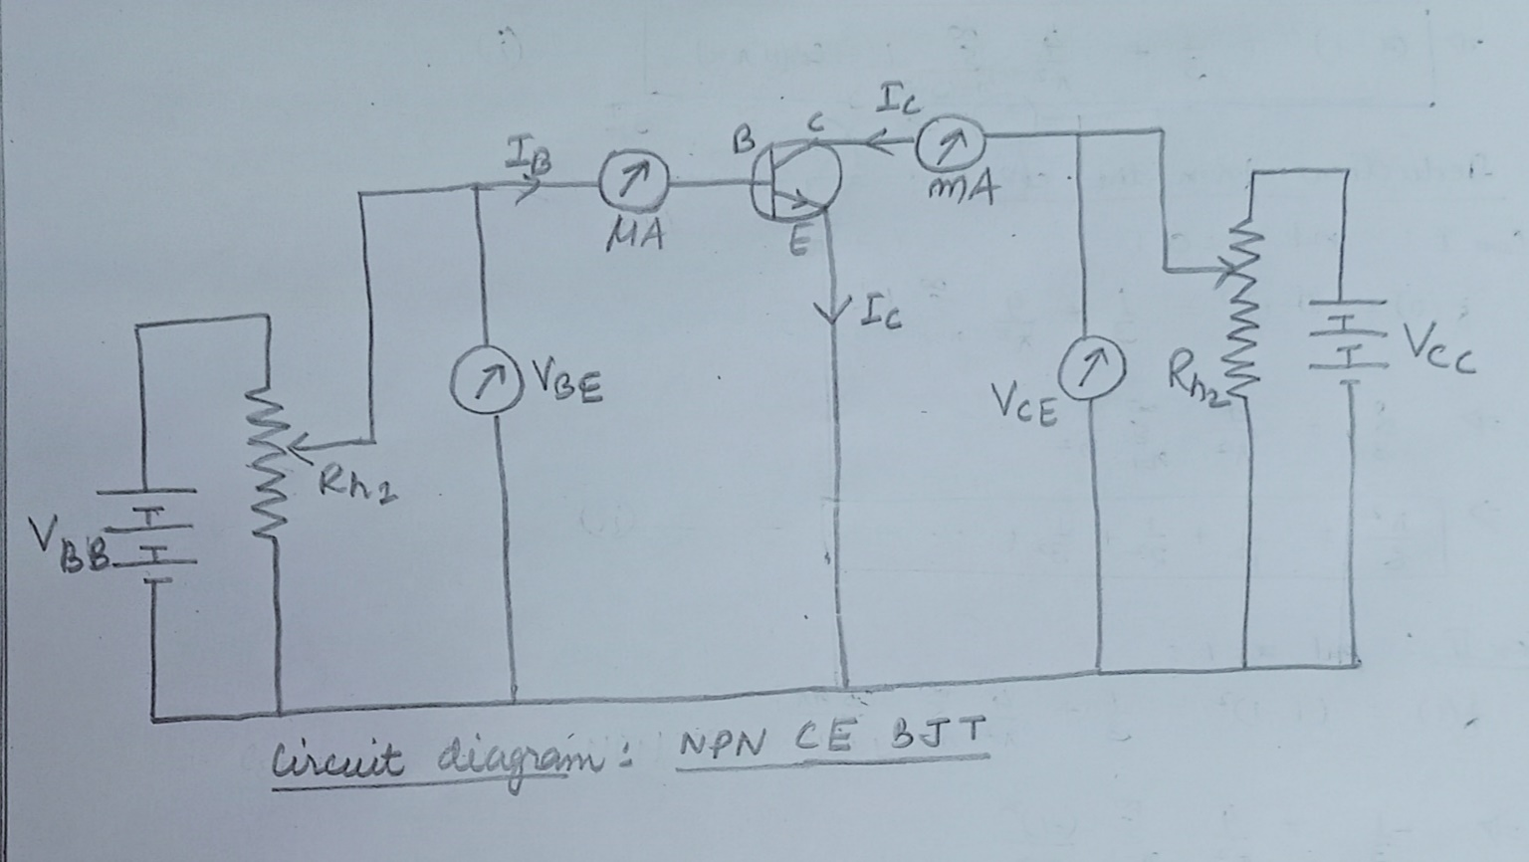

**EXPERIMENTAL DATA:**

**Input Characteristics –**

|  |  |  |  |  |  |  |  |  |  |  |  |  |  |  |  |  |  |  |  |  |  |  |  |  |  |  |  |  |  |  |  |  |  |  |  |  |  |  |  |  |  |  |  |  |
| --- | --- | --- | --- | --- | --- | --- | --- | --- | --- | --- | --- | --- | --- | --- | --- | --- | --- | --- | --- | --- | --- | --- | --- | --- | --- | --- | --- | --- | --- | --- | --- | --- | --- | --- | --- | --- | --- | --- | --- | --- | --- | --- | --- | --- |
| |  |  |  | | --- | --- | --- | | **Serial No.** | **Collector-Emitter Voltage V** | | | **Base-Emitter Voltage V** | **Base Current(μA)** | | 1 | 0.02000 | 2.058 | | 2 | 0.1600 | 2.514 | | 3 | 0.2600 | 2.900 | | 4 | 0.4400 | 3.750 | | 5 | 0.6600 | 5.135 | | 6 | 0.7600 | 5.923 | | 7 | 0.8800 | 7.031 | | 8 | 1.120 | 9.906 | | 9 | 1.320 | 13.18 | | 10 | 1.520 | 17.54 | | 11 | 1.760 | 24.72 | | 12 | 1.920 | 31.06 | | 13 | 2.000 | 34.82 | |

**Table: SET 1 DATA (VCE = 1.500 V) Table: SET 2 DATA (VCE = 0.400 V)**

|  |  |  |
| --- | --- | --- |
| **Serial No.** | **Collector-Emitter Voltage V** | |
| **Base-Emitter Voltage**  VCE | **Base Current**  IB **(μA)** |
| 1 | 0.04000 | 2.118 |
| 2 | 0.1000 | 2.307 |
| 3 | 0.1200 | 2.374 |
| 4 | 0.2400 | 2.818 |
| 5 | 0.4600 | 3.859 |
| 6 | 0.6000 | 4.713 |
| 7 | 0.8200 | 6.453 |
| 8 | 1.000 | 8.345 |
| 9 | 1.180 | 10.79 |
| 10 | 1.420 | 15.21 |
| 11 | 1.640 | 20.82 |
| 12 | 1.820 | 26.93 |

**Input Characteristics Graph for CE N-P-N BJT -**

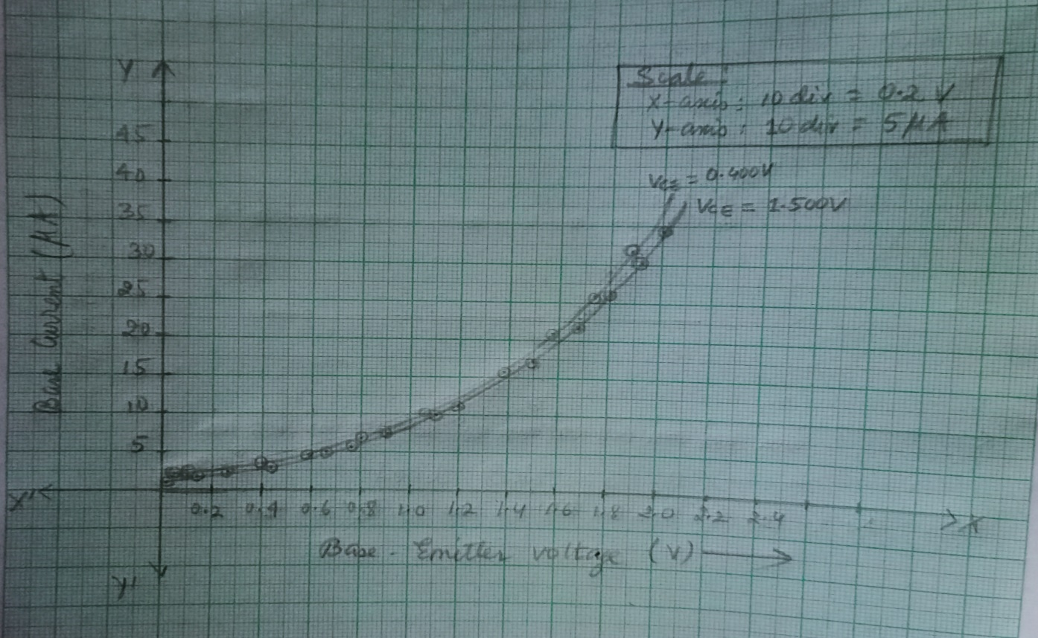

**Screenshots attached:**

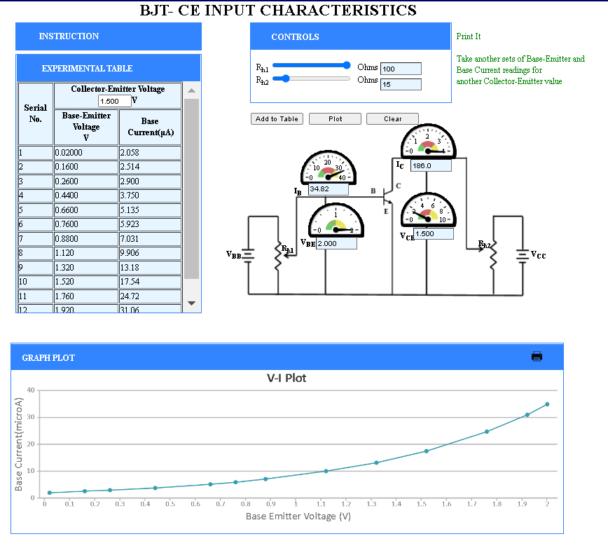

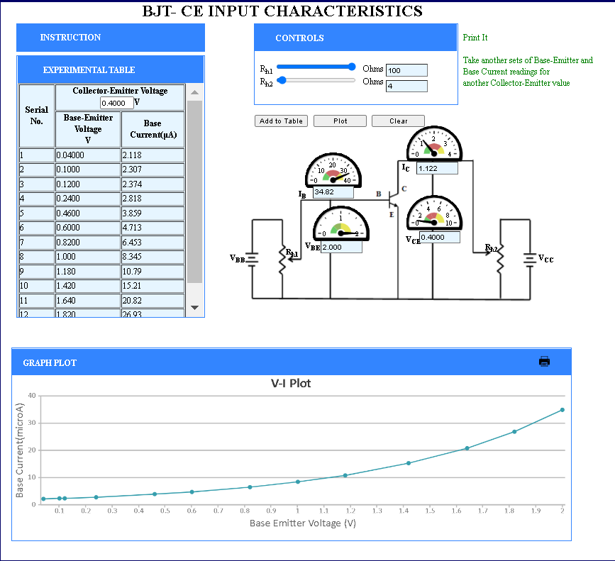

**Output Characteristics -**

**Table: SET 1 DATA (IB = 12.57 µA)**

|  |  |  |
| --- | --- | --- |
| **Serial No.** | **Base-Current μA** | |
| **Collector-Emitter Voltage V** | **Collector Current mA** |
| 1 | 0.5000 | 20.59 |
| 2 | 0.9000 | 31.91 |
| 3 | 1.100 | 35.67 |
| 4 | 1.900 | 42.61 |
| 5 | 2.500 | 43.96 |
| 6 | 3.100 | 44.37 |
| 7 | 4.000 | 44.53 |
| 8 | 5.500 | 44.55 |
| 9 | 6.100 | 44.56 |
| 10 | 6.800 | 44.56 |
| 11 | 7.600 | 44.56 |
| 12 | 8.600 | 44.56 |
| 13 | 9.400 | 44.56 |
| 14 | 10.00 | 44.56 |

**Table: SET 2 DATA (IB = 20.43 µA)**

|  |  |  |
| --- | --- | --- |
| **Serial No.** | **Base-Current μA** | |
| **Collector-Emitter Voltage V** | **Collector Current mA** |
| 1 | 0.3000 | 26.90 |
| 2 | 0.7000 | 55.80 |
| 3 | 1.000 | 70.31 |
| 4 | 1.400 | 81.74 |
| 5 | 2.000 | 89.00 |
| 6 | 3.200 | 92.02 |
| 7 | 3.900 | 92.25 |
| 8 | 6.000 | 92.32 |
| 9 | 7.000 | 92.32 |
| 10 | 8.100 | 92.32 |
| 11 | 9.100 | 92.32 |
| 12 | 10.00 | 92.32 |

**Table: SET 3 DATA (IB = 23.56 µA)**

|  |  |  |
| --- | --- | --- |
| **Serial No.** | **Base-Current μA** | |
| **Collector-Emitter Voltage V** | **Collector Current mA** |
| 1 | 0.1000 | 11.40 |
| 2 | 0.7000 | 69.13 |
| 3 | 1.400 | 101.3 |
| 4 | 2.000 | 110.3 |
| 5 | 2.600 | 113.1 |
| 6 | 3.000 | 113.8 |
| 7 | 3.600 | 114.2 |
| 8 | 4.200 | 114.3 |
| 9 | 5.400 | 114.4 |
| 10 | 6.300 | 114.4 |
| 11 | 7.600 | 114.4 |
| 12 | 8.700 | 114.4 |
| 13 | 9.700 | 114.4 |
| 14 | 10.00 | 114.4 |

**Output Characteristics Graph for CE N-P-N BJT -**

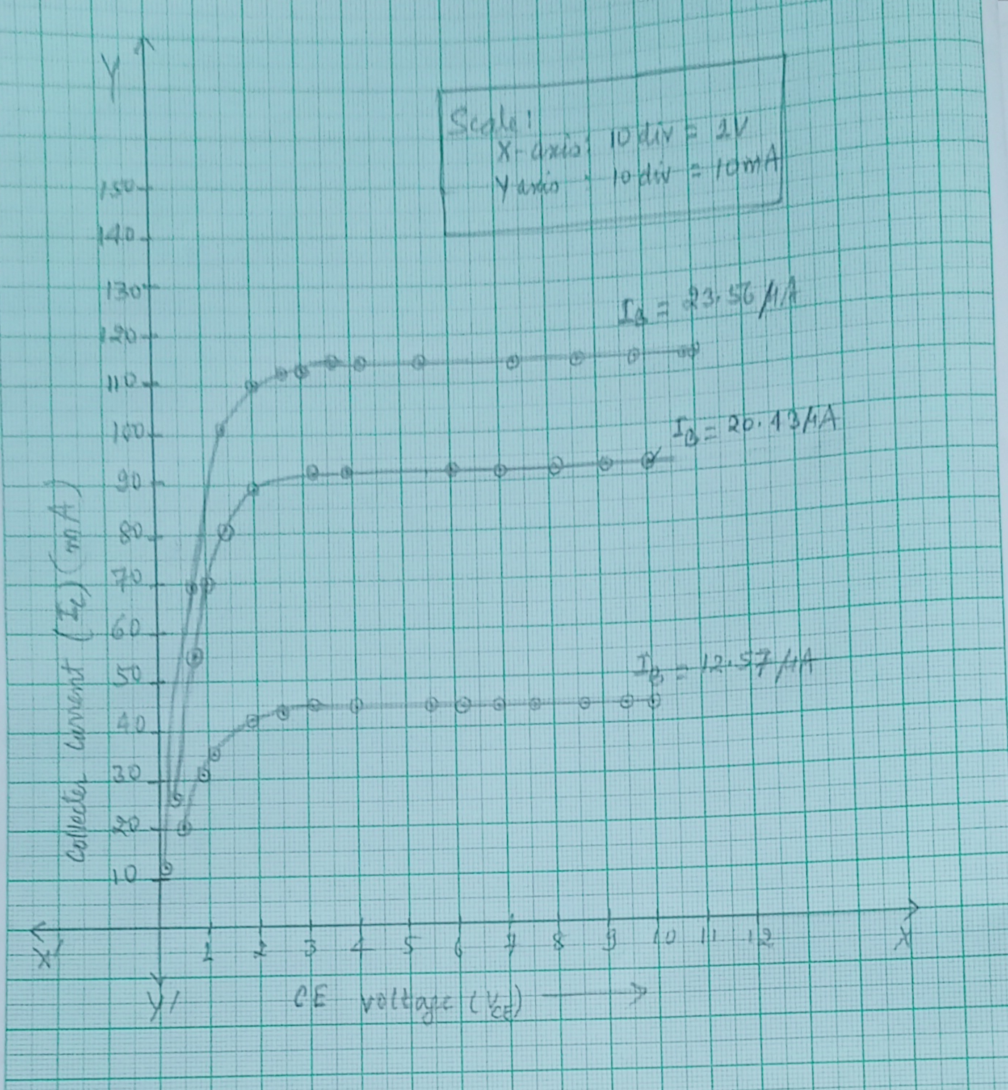

**Screenshot attached:**

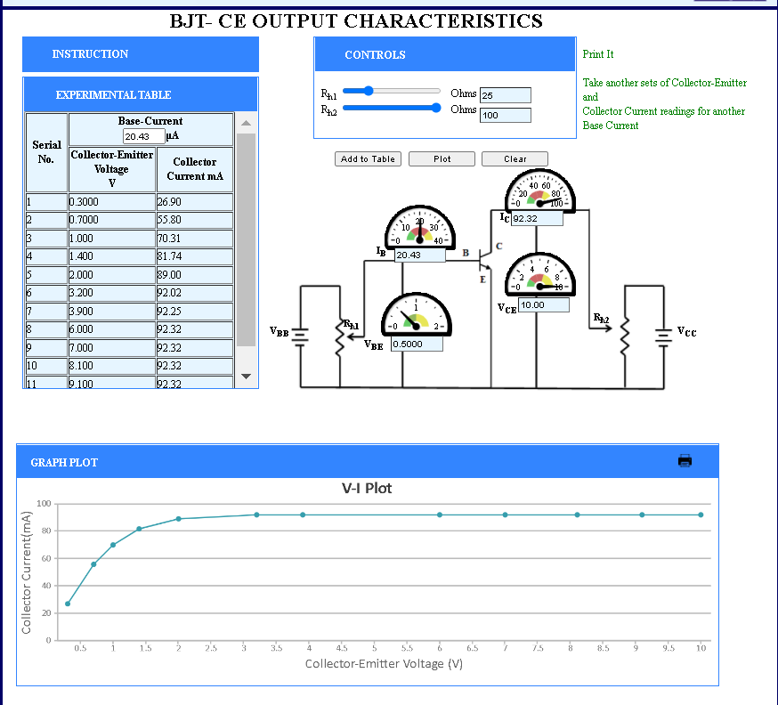

**CONCLUSION**: The Input and Output Characteristics Curve for Common Emitter (CE) mode were studied and the graphs were plotted for different values.

**Experiment – 8**

**AIM:**

Study the Input and Output Characteristics Curve for BJT Common Base (CB) mode.

**THEORY**:

A Common Base Bipolar Junction Transistor, BJT, is a single piece of silicon with two back-to-back P-N junctions. BJTs can be made either as PNP or as NPN. They have three regions and three terminals, Emitter, Base, and Collector represented by E, B, and C respectively. The direction of the arrow indicates the direction of the current in the emitter when the transistor is conducting normally.

**N-P-N**  **P-N-P**

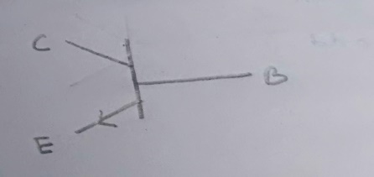 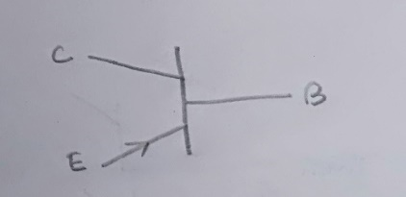

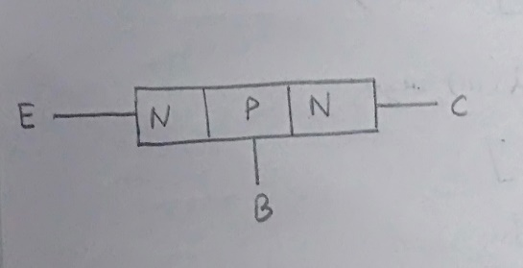 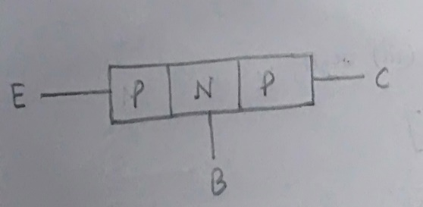

Emitter is the region to the left end which supply free charge carriers i.e., electrons in n-p-n or holes in p-n-p transistors. Base is the middle very thin and lightly doped region where either two p-type layers or two n-type layers are sandwiched. The majority carriers from the emitter region are injected into this region. Collector is the region with intermediate doping to the right end where charge carriers are collected. The area of this region is largest compared to emitter and base region.

**Input Characteristics -**

The most important characteristic of the BJT is the plot of the base current, IB, versus the base-emitter voltage, VBE, for various values of the collector-emitter voltage, VCE



**Output Characteristics -**

The most important characteristic of the BJT is the plot of the collector current, IC, versus the collector-emitter voltage, VCE for various values of the base current, IB as shown on the circuit on the right.



**Circuit Diagram: NPN CB BJT connected for study of input and output characteristics**

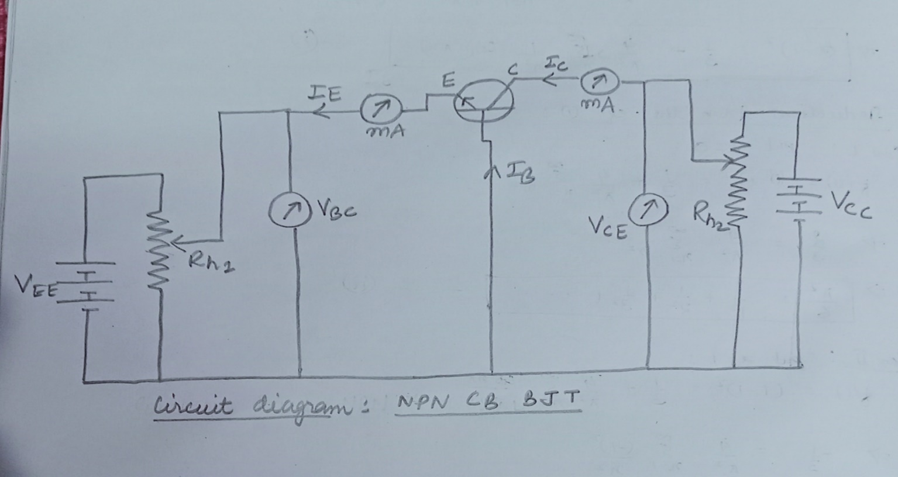

**EXPERIMENTAL DATA:**

**Input Characteristics –**

|  |  |  |
| --- | --- | --- |
| **Serial No.** | **Base-Collector Voltage V** | |
| **Base-Emitter Voltage V** | **Emitter Current mA** |
| 1 | 0.02000 | 0.76 |
| 2 | 0.08000 | 0.82 |
| 3 | 0.2400 | 1.0 |
| 4 | 0.3600 | 1.2 |
| 5 | 0.5000 | 1.5 |
| 6 | 0.6000 | 1.7 |
| 7 | 0.7600 | 2.2 |
| 8 | 0.9200 | 2.7 |
| 9 | 1.080 | 3.4 |
| 10 | 1.240 | 4.3 |
| 11 | 1.420 | 5.6 |
| 12 | 1.560 | 6.8 |
| 13 | 1.800 | 9.6 |
| 14 | 2.000 | 13 |

**Table: SET 1 DATA (VBC = 1.00V) Table: SET 2 DATA(VBC = 0.100 V)**

|  |  |  |
| --- | --- | --- |
| **Serial No.** | **Base-Collector Voltage V** | |
| **Base-Emitter Voltage V** | **Emitter Current mA** |
| 1 | 0.02000 | 0.76 |
| 2 | 0.1200 | 0.87 |
| 3 | 0.2600 | 1.1 |
| 4 | 0.4200 | 1.3 |
| 5 | 0.6200 | 1.8 |
| 6 | 0.8000 | 2.3 |
| 7 | 0.9800 | 3.0 |
| 8 | 1.200 | 4.1 |
| 9 | 1.420 | 5.6 |
| 10 | 1.580 | 7.0 |
| 11 | 1.780 | 9.4 |
| 12 | 2.000 | 13 |

**Input Characteristics Graph for CB N-P-N BJT** -

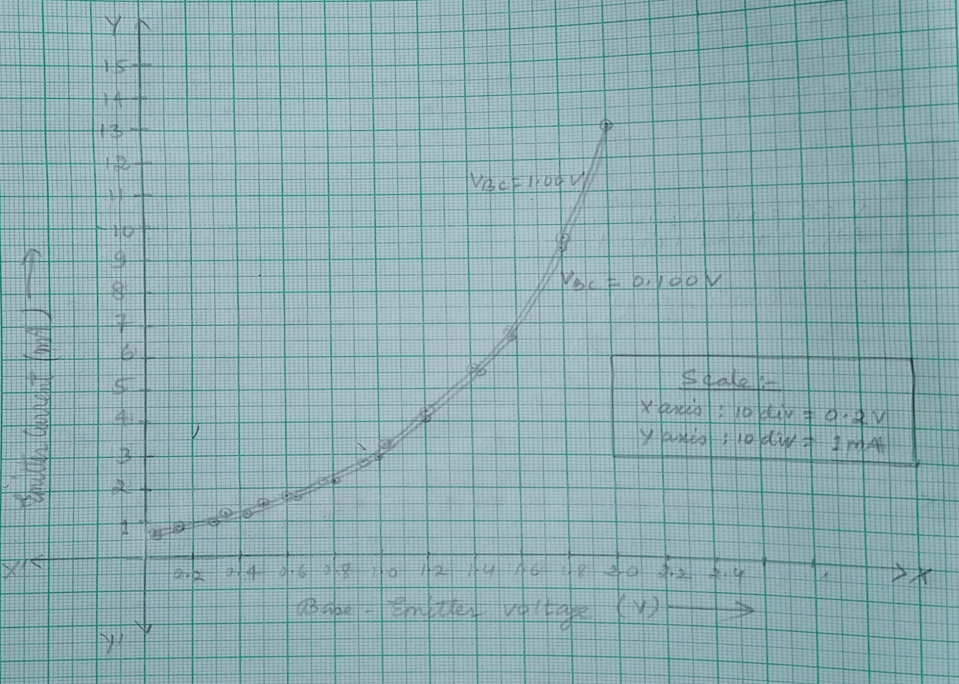

**Screenshot attached:**

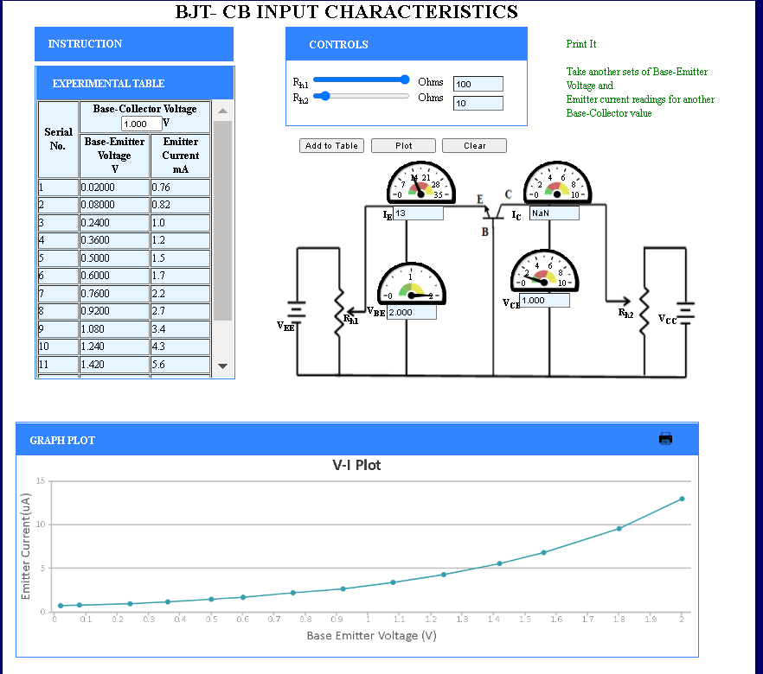

**Output Characteristics –**

**Table: SET 1 DATA (IE = 0.98 mA) Table: SET 2 DATA (IE = 1.5 mA)**

|  |  |  |
| --- | --- | --- |
| **Serial No.** | **Emitter Current mA** | |
| **Base-Collector Voltage V** | **Collector Current mA** |
| 1 | -0.1000 | -0.09757 |
| 2 | 0.1000 | 0.09757 |
| 3 | 0.4000 | 0.3720 |
| 4 | 1.000 | 0.7456 |
| 5 | 1.600 | 0.9023 |
| 6 | 2.100 | 0.9501 |
| 7 | 2.700 | 0.9702 |
| 8 | 3.300 | 0.9763 |
| 9 | 4.800 | 0.9789 |
| 10 | 5.700 | 0.9790 |
| 11 | 6.600 | 0.9790 |
| 12 | 7.500 | 0.9790 |
| 13 | 8.100 | 0.9790 |
| 14 | 9.000 | 0.9790 |
| 15 | 9.800 | 0.9790 |

|  |  |  |
| --- | --- | --- |
| **Serial No.** | **Emitter Current mA** | |
| **Base-Collector Voltage V** | **Collector Current mA** |
| 1 | -0.4000 | -0.5711 |
| 2 | -0.1000 | -0.1498 |
| 3 | 0.2000 | 0.2967 |
| 4 | 0.5000 | 0.6946 |
| 5 | 0.8000 | 0.9980 |
| 6 | 1.700 | 1.406 |
| 7 | 2.000 | 1.449 |
| 8 | 2.400 | 1.478 |
| 9 | 3.000 | 1.496 |
| 10 | 3.600 | 1.501 |
| 11 | 4.000 | 1.502 |
| 12 | 5.300 | 1.503 |
| 13 | 6.700 | 1.503 |
| 14 | 8.000 | 1.503 |
| 15 | 9.500 | 1.503 |

**Table: SET 3 DATA (IE = 2.0 mA)**

|  |  |  |
| --- | --- | --- |
| **Serial No.** | **Emitter Current mA** | |
| **Base-Collector Voltage V** | **Collector Current mA** |
| 1 | -0.6000 | -1.074 |
| 2 | -0.1000 | -0.1993 |
| 3 | 0.3000 | 0.5826 |
| 4 | 0.9000 | 1.433 |
| 5 | 1.500 | 1.810 |
| 6 | 2.000 | 1.928 |
| 7 | 2.400 | 1.967 |
| 8 | 2.600 | 1.978 |
| 9 | 2.800 | 1.985 |
| 10 | 3.200 | 1.993 |
| 11 | 3.400 | 1.996 |
| 12 | 5.300 | 2.000 |
| 13 | 6.400 | 2.000 |
| 14 | 7.700 | 2.000 |
| 15 | 9.300 | 2.000 |

**Output Characteristics Graph for CB N-P-N BJT –**

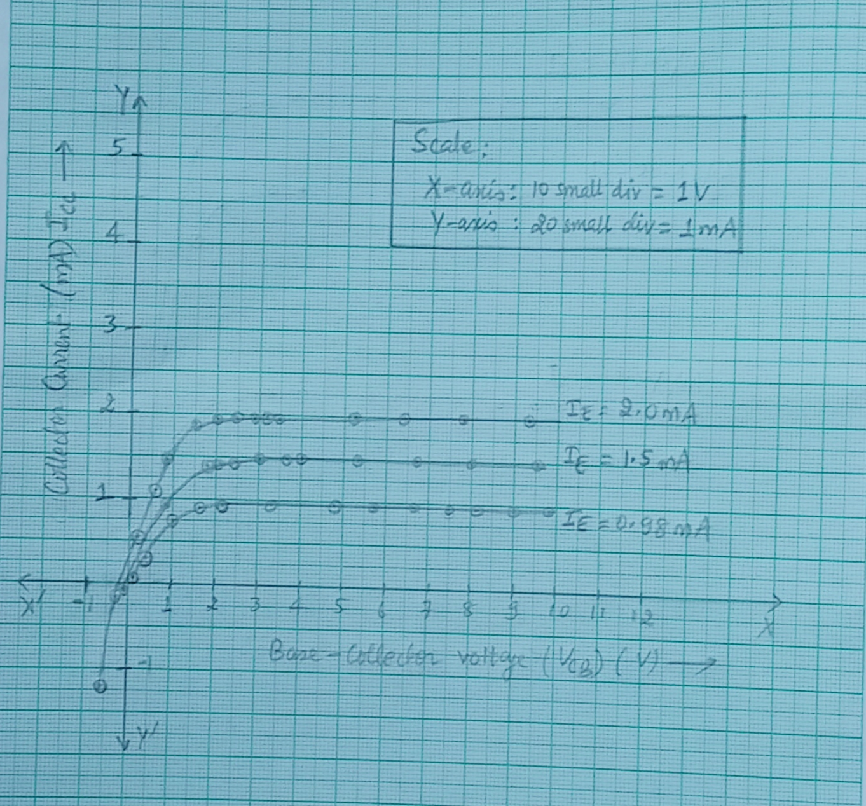

**Screenshot attached:**

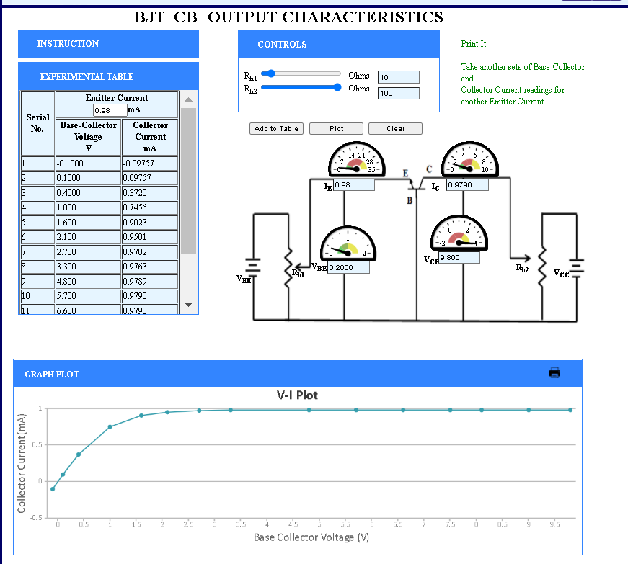

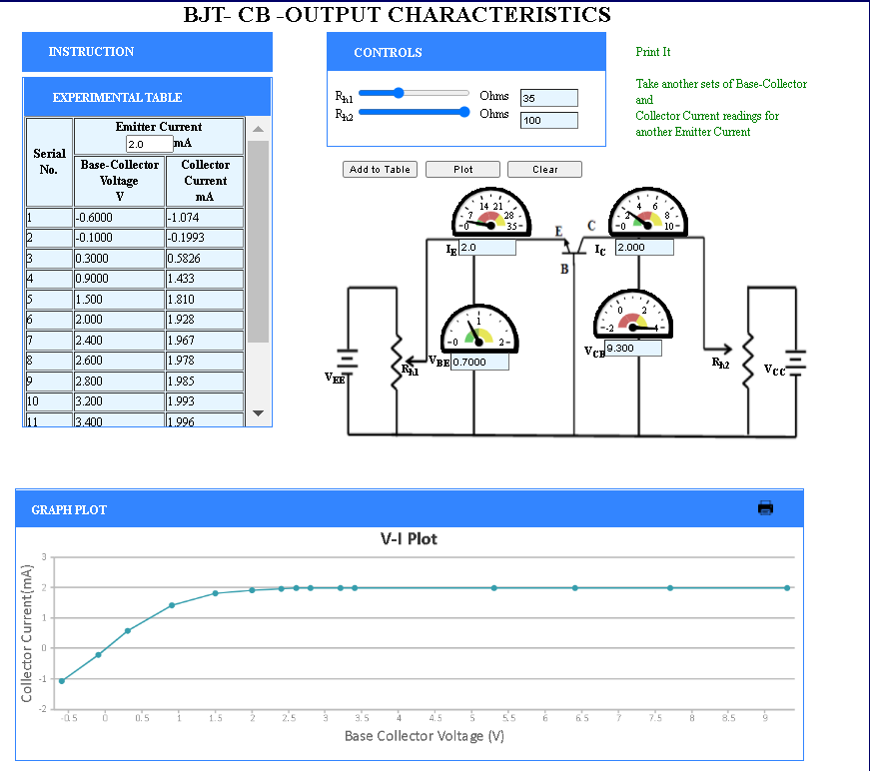

**CONCLUSION**: The Input and Output Characteristics Curve for Common Base (CB) mode BJT were studied and the graphs were plotted.

**Experiment - 9:**

**Aim:-** Study of Op-Amp circuits: Inverting and Non-Inverting amplifiers.

**Theory:-** Operational Amplifier commonly known as Op-Amp is a linear electronic device having three terminals, two high impedance input and one output terminal. Op-Amp can perform multiple function when attached to different feedback combinations like resistive, capacitive or both. Generally it is used as voltage amplifier and the output voltage of the Op-Amp is the difference between the voltages at its two input terminals. Op-Amp shows some properties that make it an ideal amplifier, its open loop gain and input impedance is infinite (i.e. practically very high), Output impedance and offset voltage is zero(i.e., practically very low) and bandwidth is infinite(i.e. practically limited to frequency where its gain become unity)

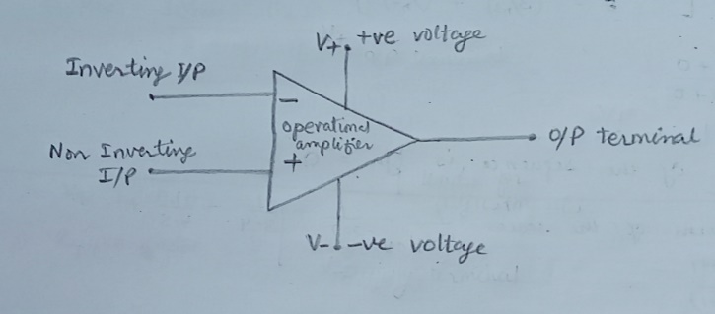

**Invering Op-Amp:-**

The open loop gain(AO) of the Op-Amp is very high which makes it very unstable, so to make it stable with a controllable gain, a feedback is applied through some external resistor(RF ) from its output to inverting input terminal(i.e., also known as negative feedback) resulting in reduced gain(closed loop gain, AV ). So the voltage at inverting terminal is now the sum of the actual input and feedback voltages, and to separate both a input resistor (RI ) is introduced in the circuit. The non-Inverting terminal of the Op-Amp is grounded, and the inverting terminal behaves like a virtual ground as the junction of the input and feedback signal are at the same potential. 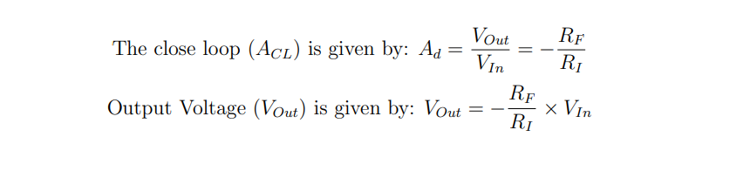

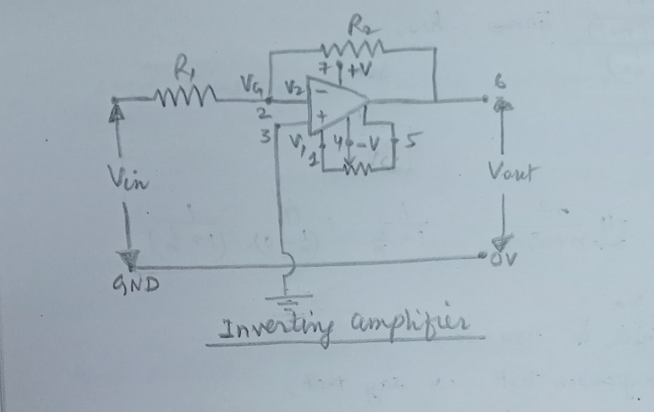

**Non-Invering Op-Amp:-**

In this configuration of Op-amp the input signal is directly fed to the non-inverting terminal resulting in a positive gain and output voltage in phase with input as compared to inverting Op-amp where the gain is negative and output voltage is out of phase with input, and to stabilize the circuit a negative feedback is applied through a resistor (RF ) and the inverting terminal is grounded with an input resistor (R2). This inverting Op-Amp like layout the at inverting terminal creates a virtual ground at the summing point make the RF and R2 a potential divider across inverting terminal, hence determines the gain of the circuit. 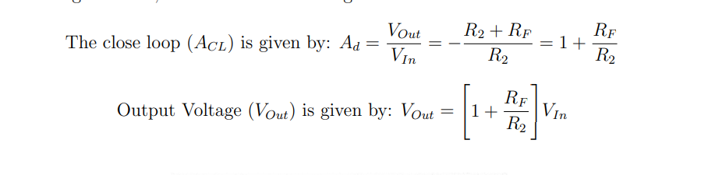

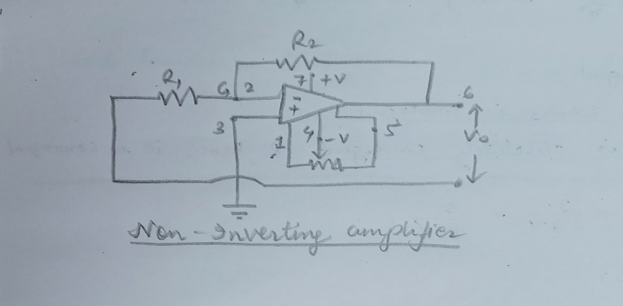

**Experimental Data:**

**Inverting op-amp:**

**Table 1: Table 2:**

|  |  |  |  |
| --- | --- | --- | --- |
| **Serial No.** | **Input Voltage V** | **Output Voltage V** | **Current mA** |
| 1 | -15 | 45.0 | -0.0583 |
| 2 | -13 | 39.0 | -0.0505 |
| 3 | -12 | 36.0 | -0.0466 |
| 4 | -10 | 30.0 | -0.0388 |
| 5 | -8 | 24.0 | -0.0311 |
| 6 | -6 | 18.0 | -0.0233 |
| 7 | -3 | 9.00 | -0.0117 |
| 8 | -1 | 3.00 | -0.00388 |
| 9 | 1 | -3.00 | 0.00388 |
| 10 | 3 | -9.00 | 0.0117 |
| 11 | 4 | -12.0 | 0.0155 |
| 12 | 7 | -21.0 | 0.0272 |
| 13 | 9 | -27.0 | 0.0350 |
| 14 | 11 | -33.0 | 0.0427 |
| 15 | 15 | -45.0 | 0.0583 |

Resistance: KΩ Resistance: KΩ

|  |  |  |  |
| --- | --- | --- | --- |
| **Serial No.** | **Input Voltage V** | **Output Voltage V** | **Current mA** |
| 1 | -15 | 150 | -1.50 |
| 2 | -13 | 130 | -1.30 |
| 3 | -11 | 110 | -1.10 |
| 4 | -9 | 90.0 | -0.900 |
| 5 | -6 | 60.0 | -0.600 |
| 6 | -4 | 40.0 | -0.400 |
| 7 | -3 | 30.0 | -0.300 |
| 8 | -1 | 10.0 | -0.100 |
| 9 | 2 | -20.0 | 0.200 |
| 10 | 0 | 0.00 | 0.00 |
| 11 | 3 | -30.0 | 0.300 |
| 12 | 7 | -70.0 | 0.700 |
| 13 | 11 | -110 | 1.10 |
| 14 | 15 | -150 | 1.50 |

**Graphs for Inverting Opamp:**

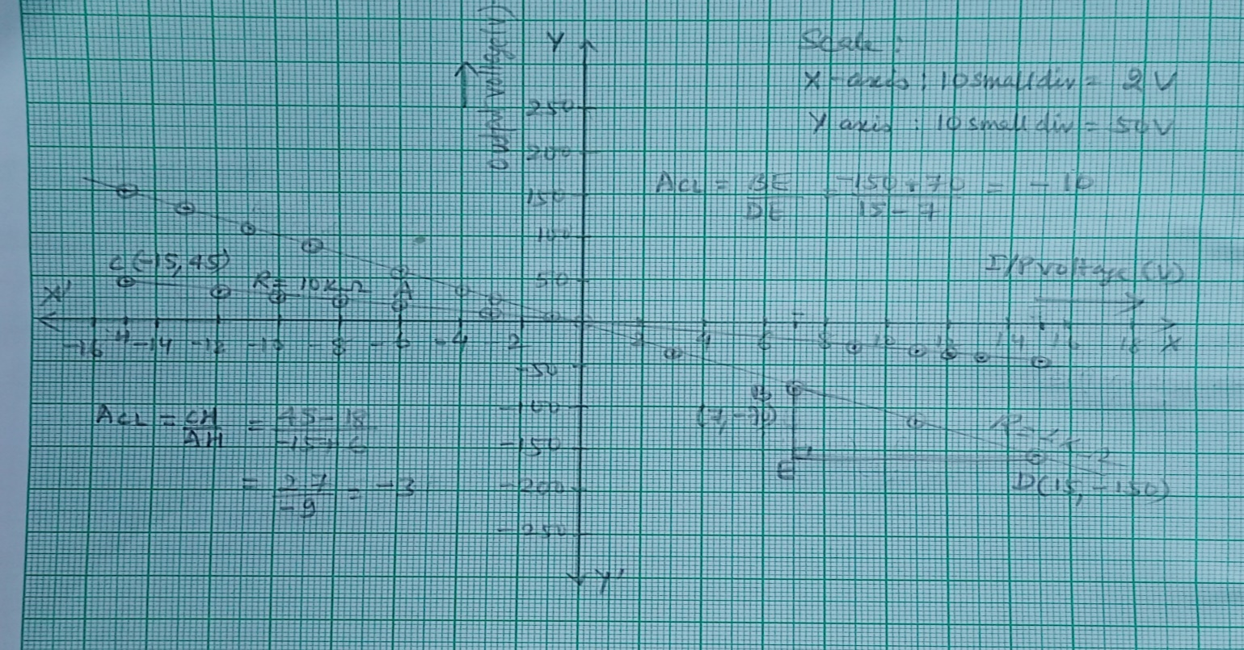

**Calculation:**

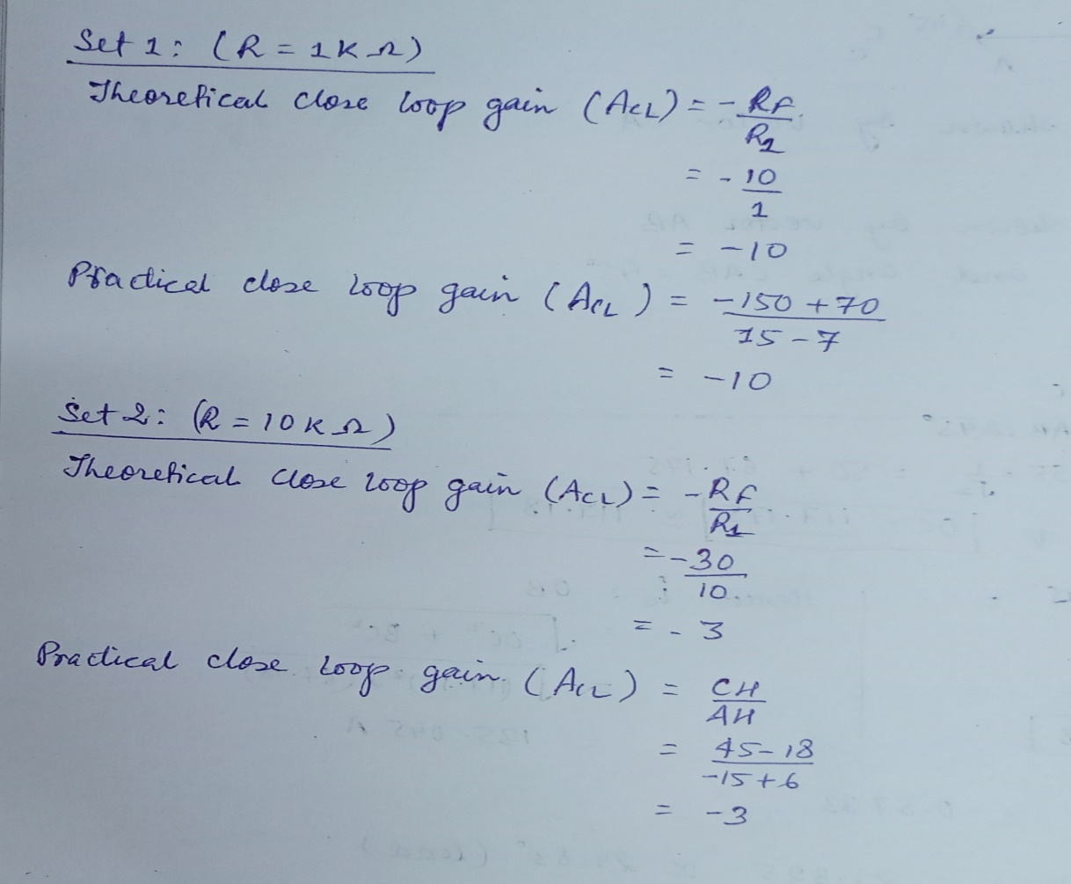

**Screenshots:**

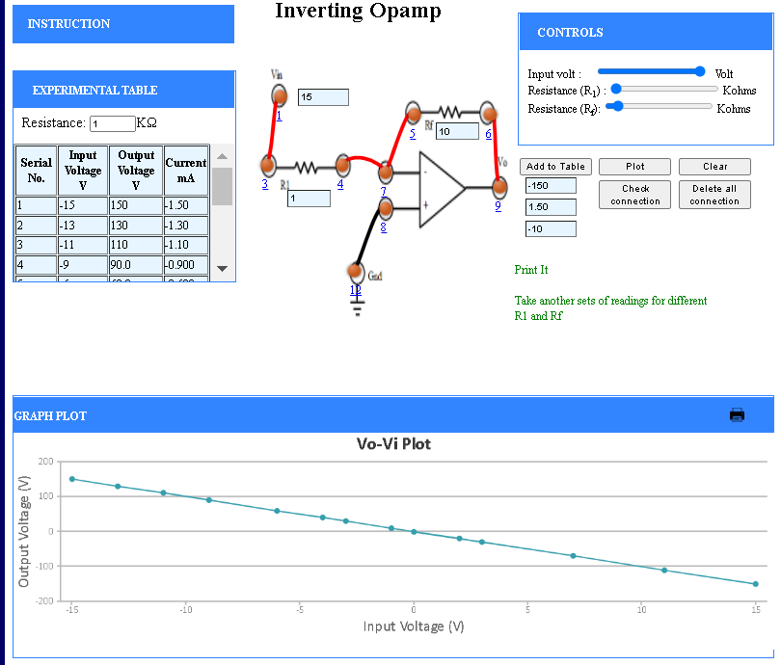

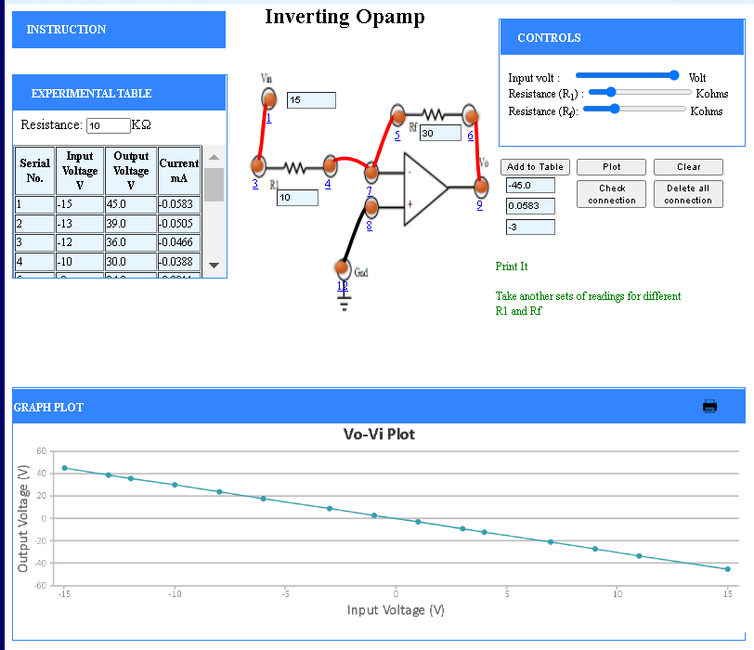

**Non-Invering Op-Amp:**

**Table - 1:**

Resistance: KΩ

|  |  |  |  |
| --- | --- | --- | --- |
| **Serial No.** | **Input Voltage V** | **Output Voltage V** | **Current mA** |
| 1 | -15 | -165 | -1.64 |
| 2 | -13 | -143 | -1.42 |
| 3 | -9 | -99.0 | -0.982 |
| 4 | -5 | -55.0 | -0.545 |
| 5 | -2 | -22.0 | -0.218 |
| 6 | 0 | 0.00 | 0.00 |
| 7 | 3 | 33.0 | 0.327 |
| 8 | 5 | 55.0 | 0.545 |
| 9 | 7 | 77.0 | 0.764 |
| 10 | 9 | 99.0 | 0.982 |
| 11 | 11 | 121 | 1.20 |
| 12 | 14 | 154 | 1.53 |
| 13 | 15 | 165 | 1.64 |

Table – 2:

Resistance: KΩ

|  |  |  |  |
| --- | --- | --- | --- |
| **Serial No.** | **Input Voltage V** | **Output Voltage V** | **Current mA** |
| 1 | -15 | -75.0 | -0.173 |
| 2 | -13 | -65.0 | -0.150 |
| 3 | -11 | -55.0 | -0.127 |
| 4 | -8 | -40.0 | -0.0923 |
| 5 | -6 | -30.0 | -0.0692 |
| 6 | -4 | -20.0 | -0.0462 |
| 7 | 0 | 0.00 | 0.00 |
| 8 | 3 | 15.0 | 0.0346 |
| 9 | 5 | 25.0 | 0.0577 |
| 10 | 7 | 35.0 | 0.0808 |
| 11 | 10 | 50.0 | 0.115 |
| 12 | 15 | 75.0 | 0.173 |

**Graph:**

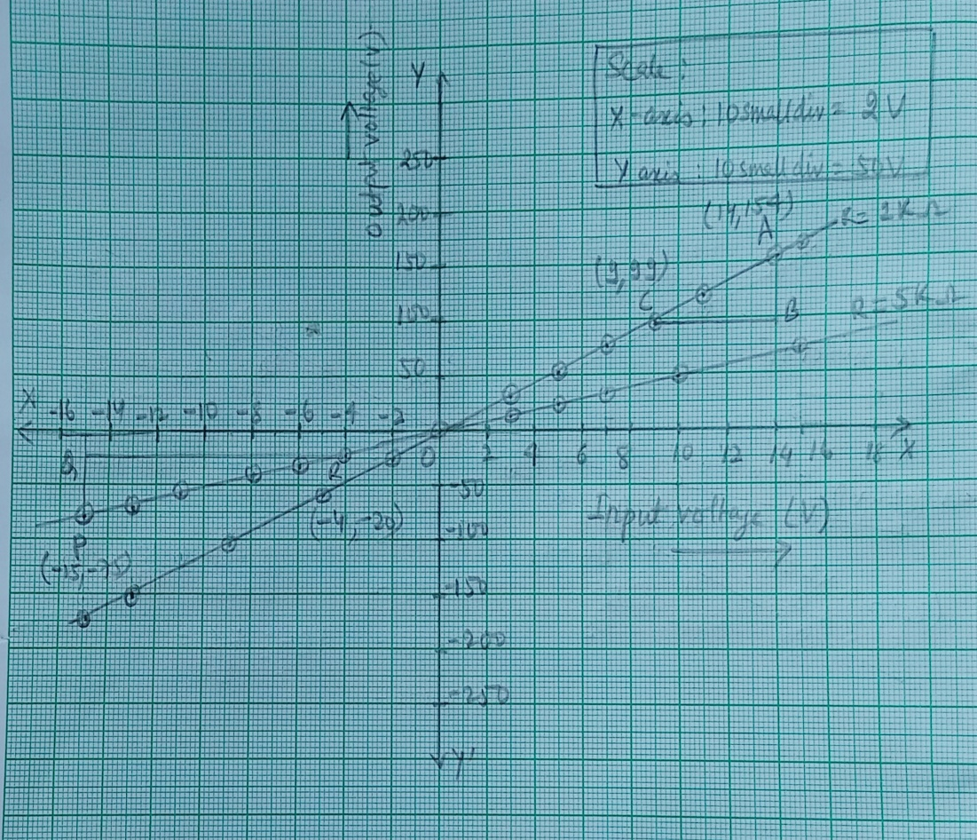

**Calculation:**

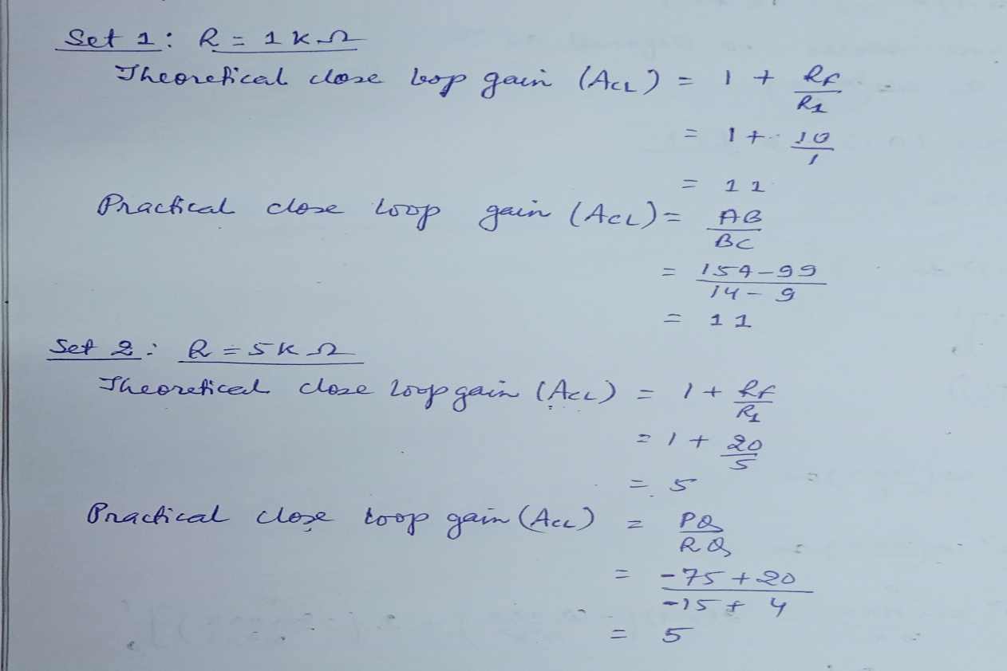

**Screenshot attached:**

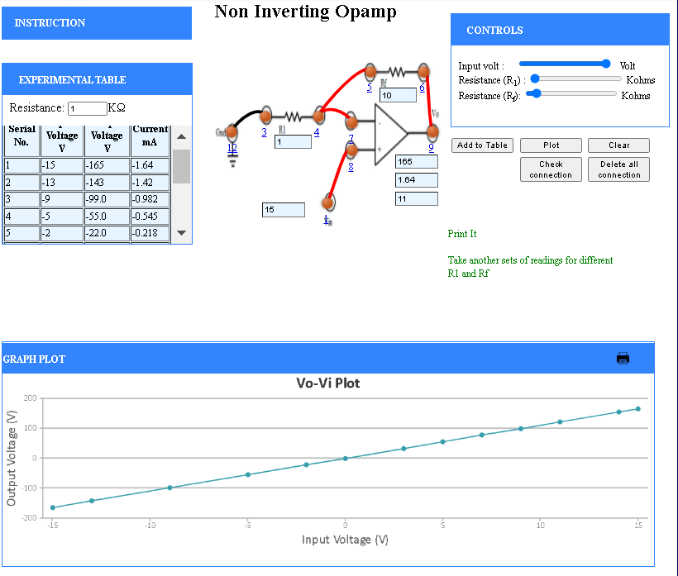

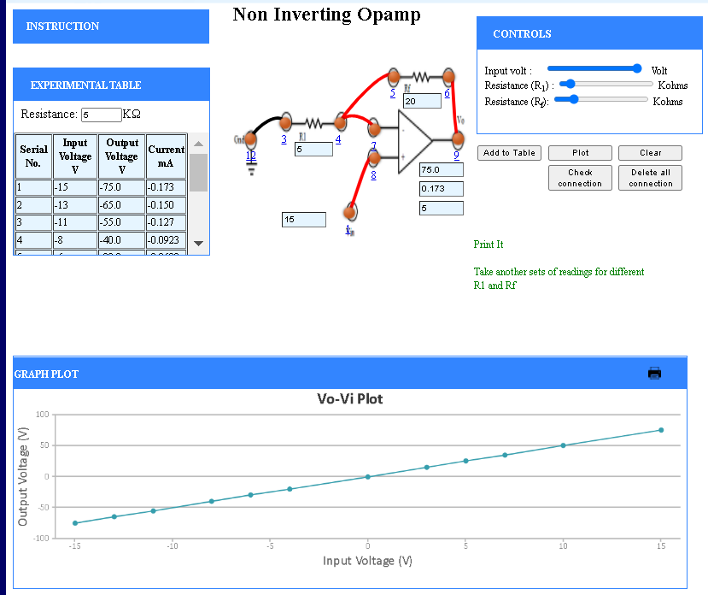

**Conclusion:-** Thus the practical and theoretical gain values match and are equal for both the Inverting and Non-Inverting OP-Amp. The screenshots are attached below.

**Experiment – 10:**

**Aim:-**

Study of Op-Amp circuits: Integrator and Differentiator using Op-Amp.

**Theory:-**

Operational Amplifier commonly known as Op-Amp is a linear electronic device having three terminals, two high impedance input and one output terminal. Op-Amp can perform multiple function when attached to different feedback combinations like resistive, capacitive or both. Generally it is used as voltage amplifier and the output voltage of the Op-Amp is the difference between the voltages at its two input terminals. Op-Amp shows some properties that make it an ideal amplifier, its open loop gain and input impedance is infinite (i.e. practically very high), Output impedance and offset voltage is zero(i.e., practically very low) and bandwidth is infinite(i.e. practically limited to frequency where its gain become unity)

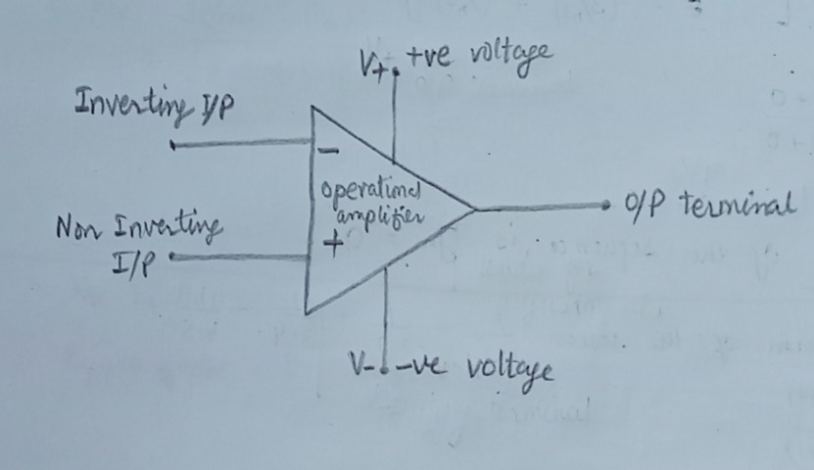

**The Integrator:-**

It is a circuit designed with Op-Amp in such a way that it performs the mathematical Integration operation, its output is proportional to the amplitude and time duration of the input applied. The integrator circuit layout is same as a inverting amplifier but the feedback resistor is replaced by a capacitor which make the circuit frequency dependent. In this case the circuit is derived by the time duration of input applied which results in the charging and discharging of the capacitor. Initially when the voltage is applied to integrator the uncharged capacitor allows maximum current to pass through it and no current flows through the Op-Amp due to the presence of virtual ground, the capacitor starts to charge at the rate of RC time constant and its impedance starts to increase with time and a potential difference is develops across the capacitor resulting in charging current to decrease. This results in the ratio of capacitor’s impedance and input resistance increasing causing a linearly increasing ramp output voltage that continues to increase until the capacitor becomes fully charged.

**The Differentiator:-**

In the differentiator circuit the input is connected to the inverting output of the Op-Amp through a capacitor (C) and a negative feedback is provided to the inverting input terminal through a resistor (RF ), which is same as an integrator circuit with feedback capacitor and input resistor being replaced with each other. Here the circuit performs a mathematical differentiation operation, and the output is the first derivative of the input signal, 180◦ out of phase and amplified with a factor RF ×C. The capacitor on the input allows only the AC component and restrict the DC, at low frequency the reactance of capacitor is very high causing a low gain and high frequency vice versa but and high frequency the circuit becomes unstable.

**Experimental Data:-**

To analyse the output signals, the following graphs were plotted and for the following experiment the values of capacitor and resistor etc. used are:

**Integrator using Op-Amp:**

- • Capacitor: 0.1 µF

• Resistance: 10 KΩ

• Frequency: 2.5 KHz

• Amplitude: 0.8V

**Integrator using Op-Amp Square Wave Plot:**

**Graph:**

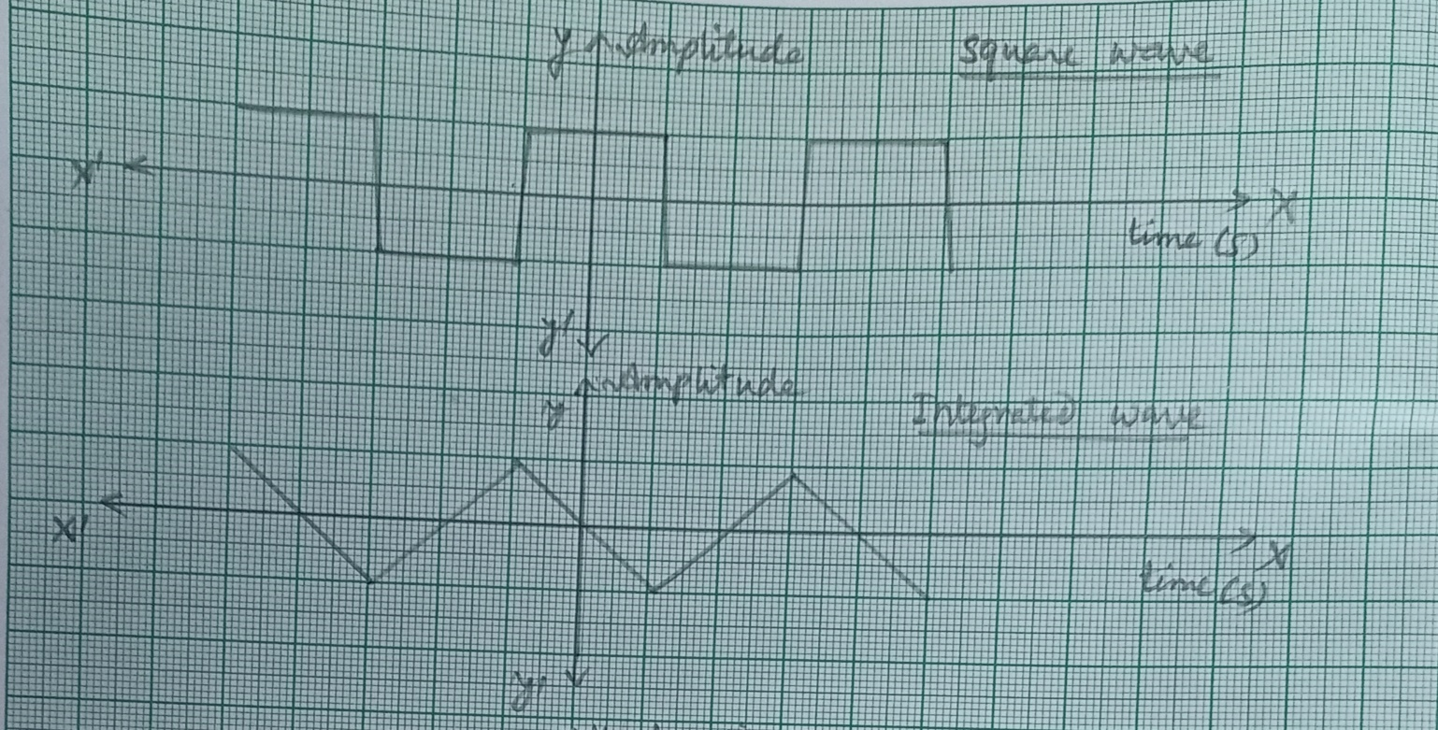

**Screenshot attached:**

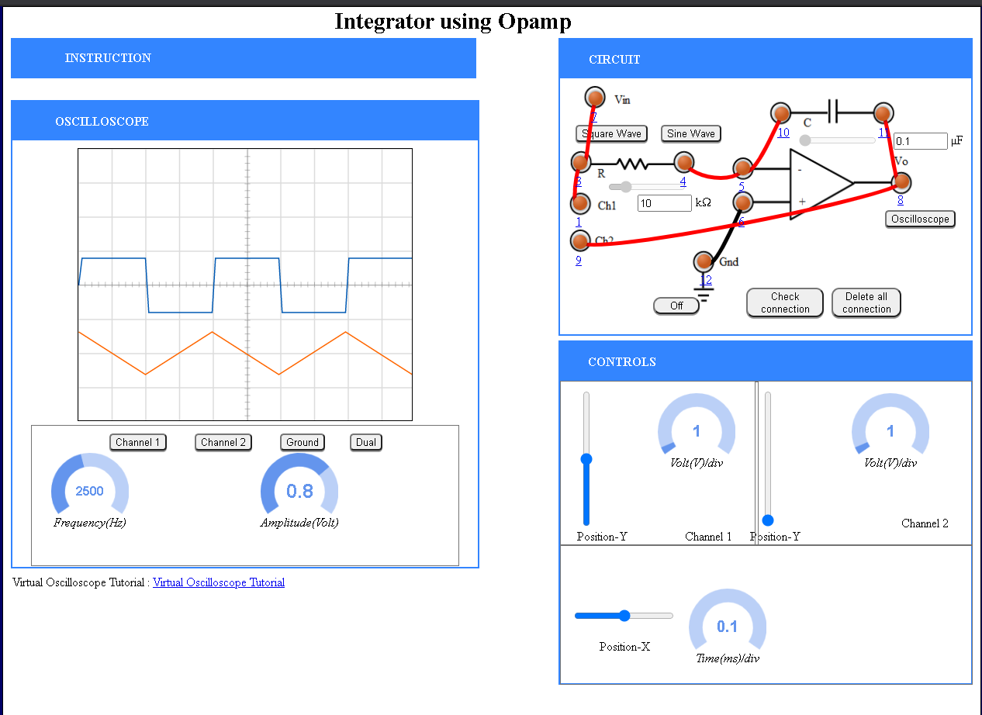

**Integrator using Op-Amp Sine Wave Plot:**

**Graph:**

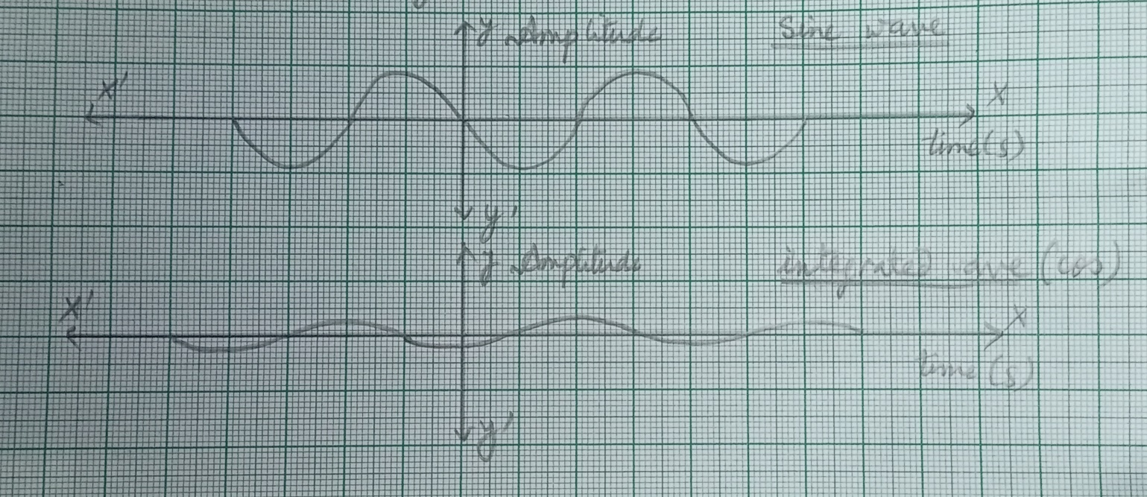

**Screenshot attached:**

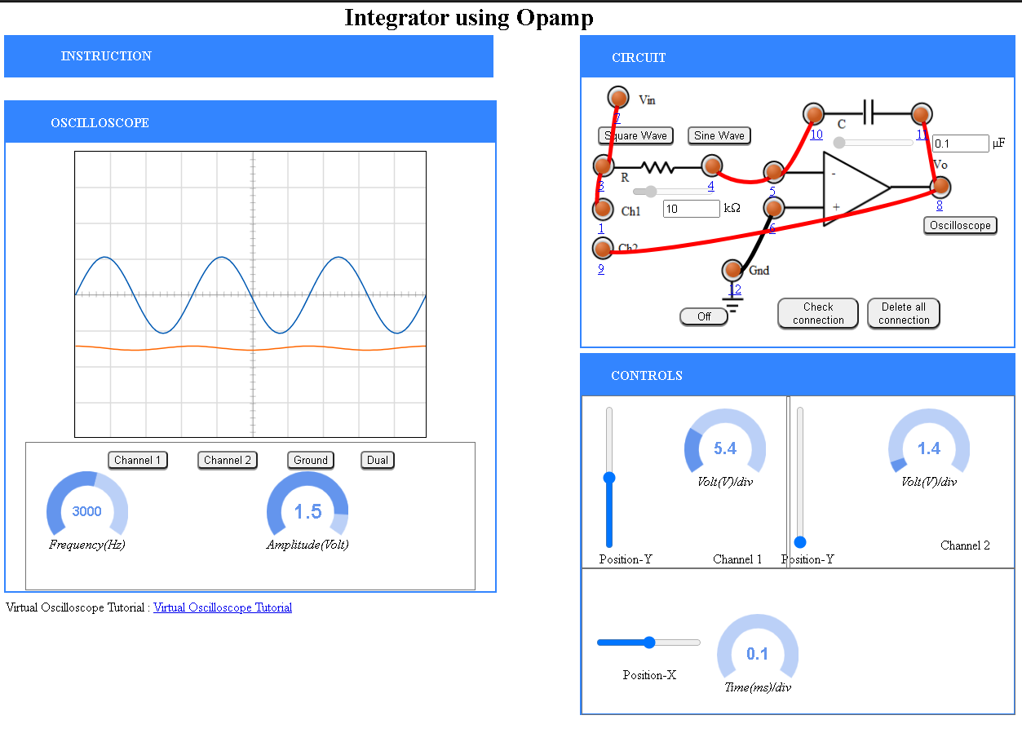

**Differentiator using Op-Amp-**

• Capacitor: 0.1 µF

• Resistance: 1 KΩ

• Frequency: 2 KHz

• Amplitude: 0.7V

**Differentiator using Op-Amp Square Wave Plot:**

**Graph:**

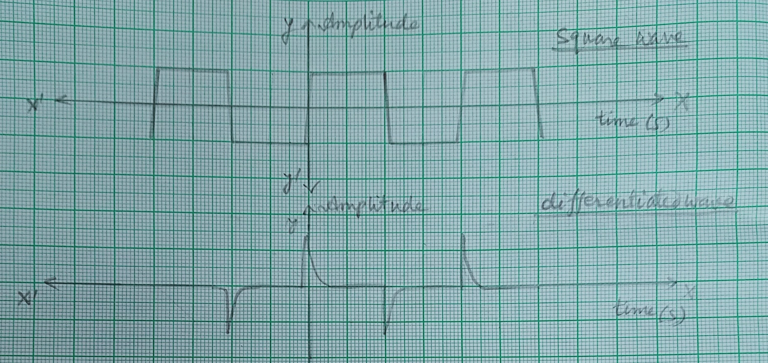

**Screenshot attached:**

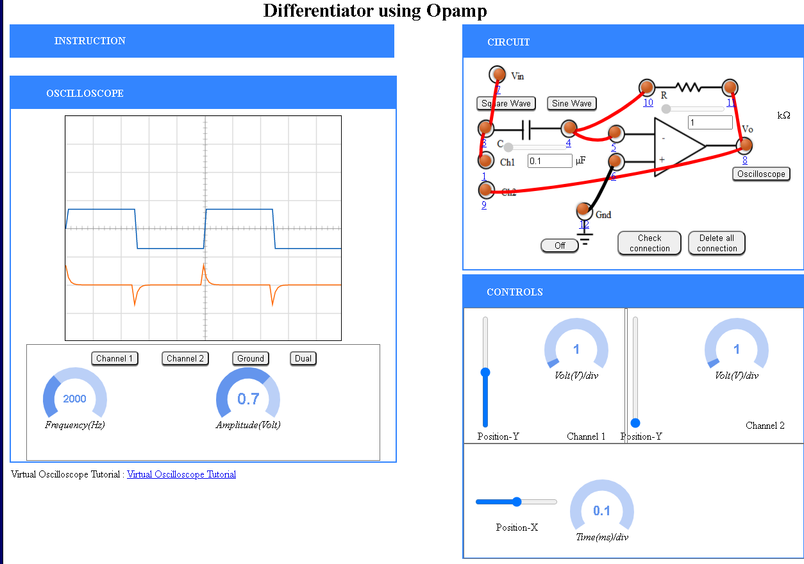

**Differentiator using Op-Amp Sine Wave Plot:**

**Graph:**

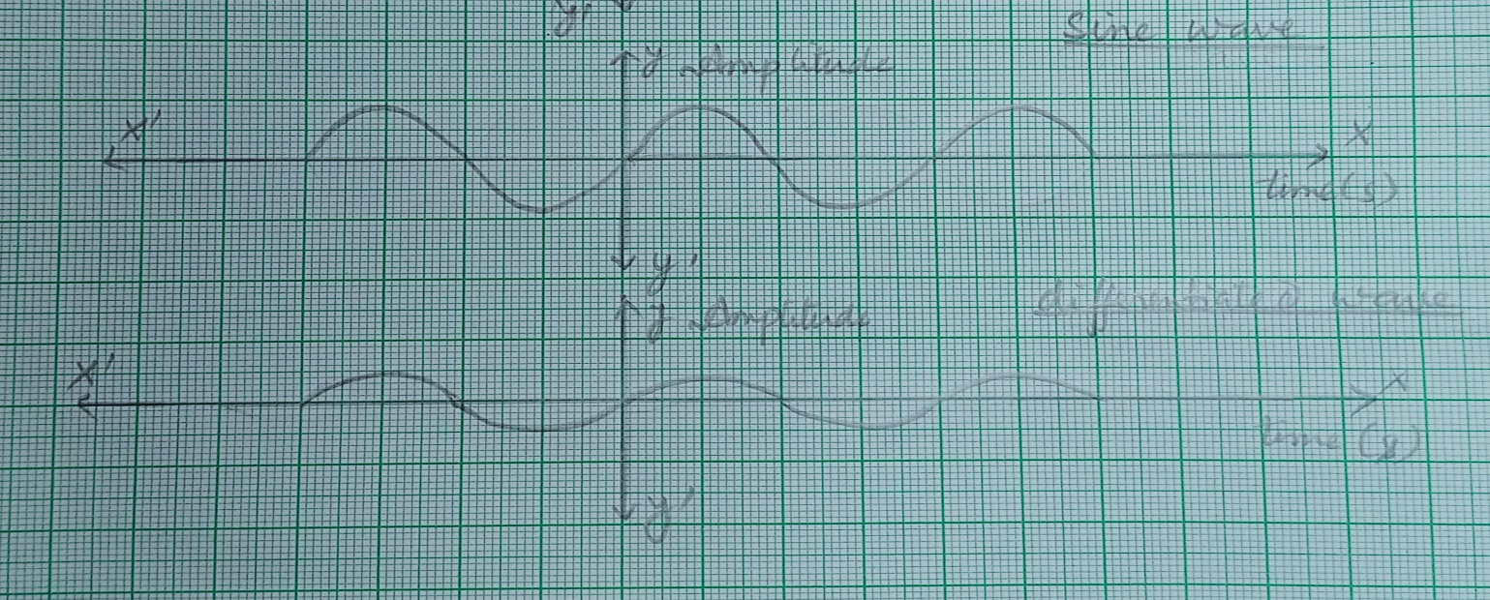

**Screenshot attached:**

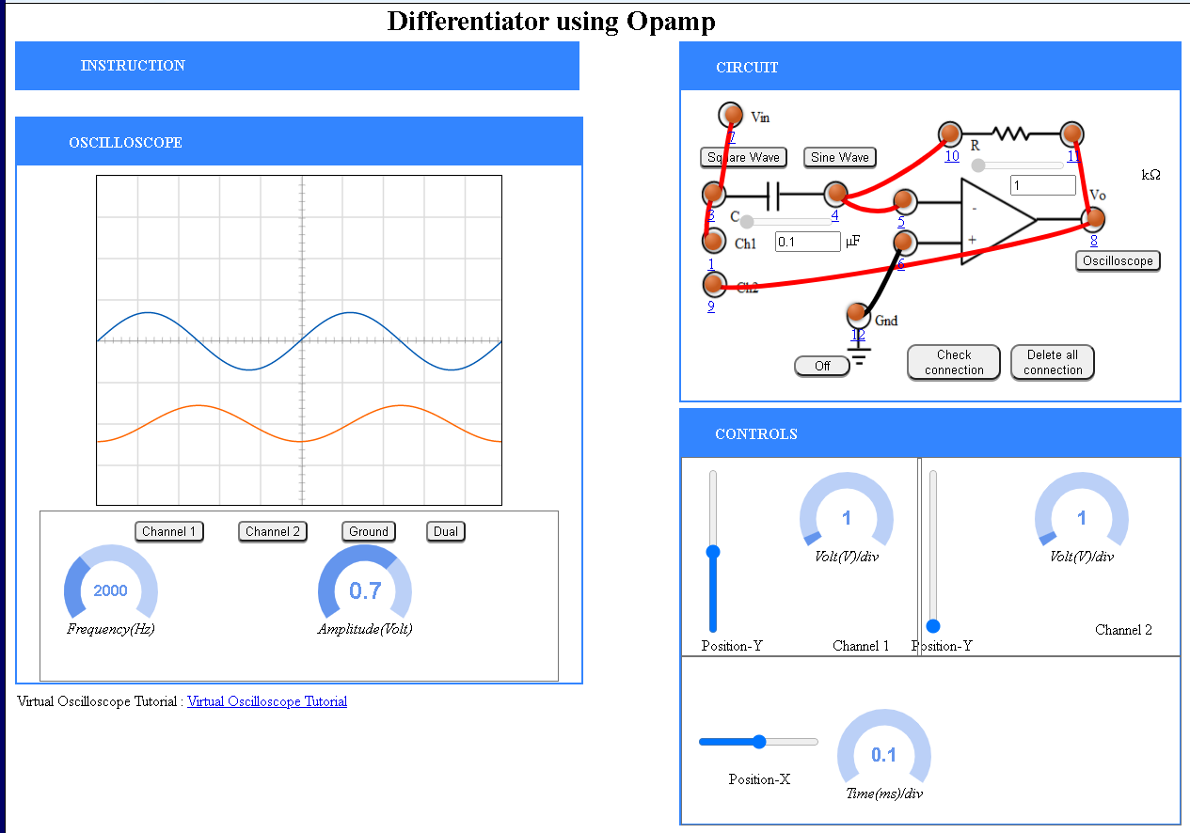

**Conclusion:-** Thus, we learnt the differentiator & integrator using operational amplifiers..

**Digital Electronics Practical:**

**Aim of the Experiment:**

The principal objective of this experiment is to fully understand the function and use of logic gates such as 7400(quad 2-input NAND gates), 7402(quad 2-input NOR gates), 7404(Hex inverter), 7408(quad 2-input AND gates) and 7432(quad 2-input OR gates) and also to learn-

1. To analyse logic gates
2. To express Boolean expression using logic gates
3. To check equivalence of two Boolean expressions using logic gates
4. To check equivalence of two logic circuits consisting of multiple gates

**THEORY**:

Analysis of Logic gates using 7400(quad 2-input NAND gates), 7402(quad 2-input NOR gates), 7404(HEX inverter), 7408(quad 2-input AND gates), 7432(quad 2-input OR gates).

NOTE - We consider output as 0 for 0 V – 0.6 V & 1 for 4.2 V – 5.0 V

Diagrams of each chip are shown below:

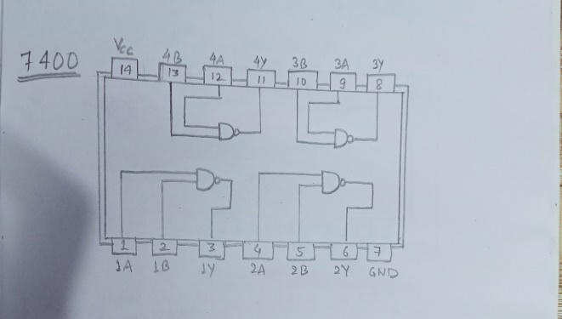 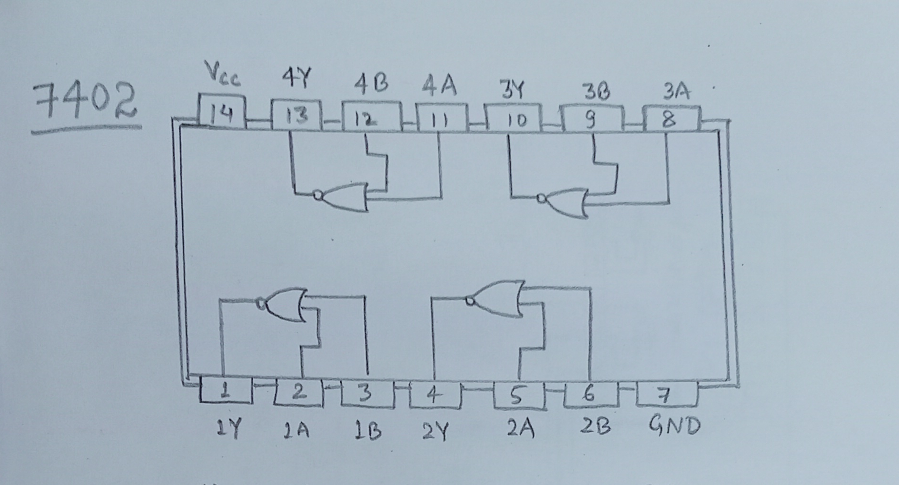

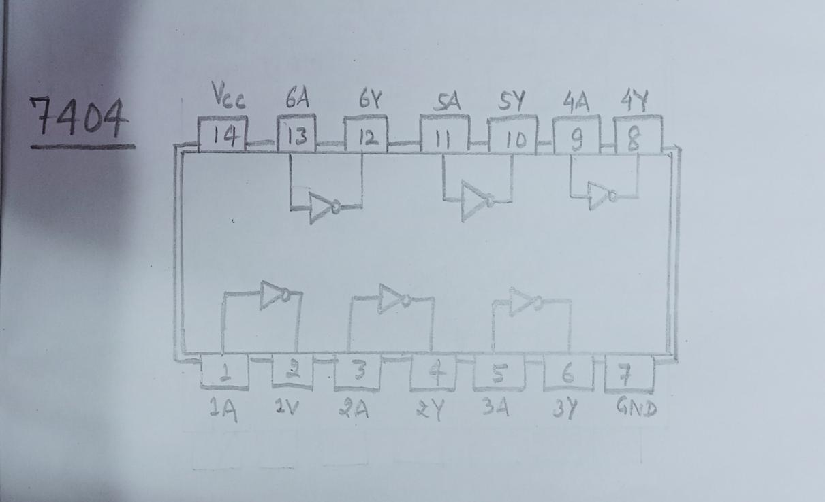 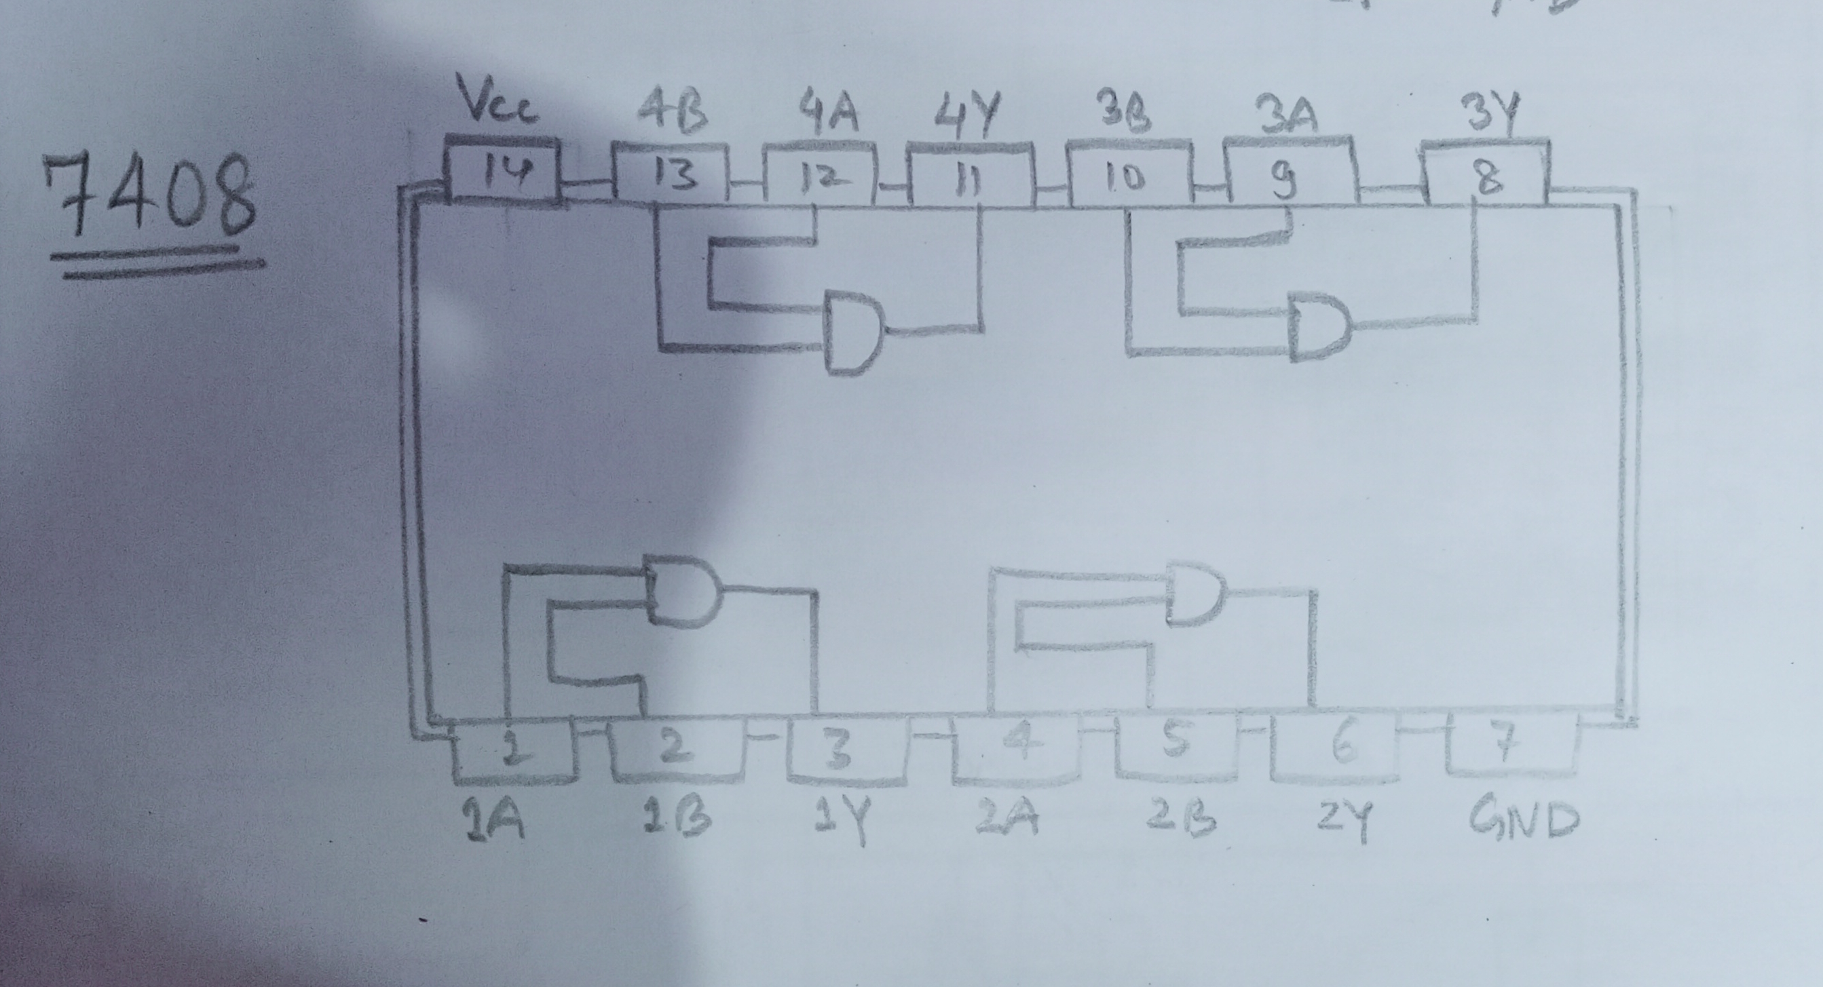

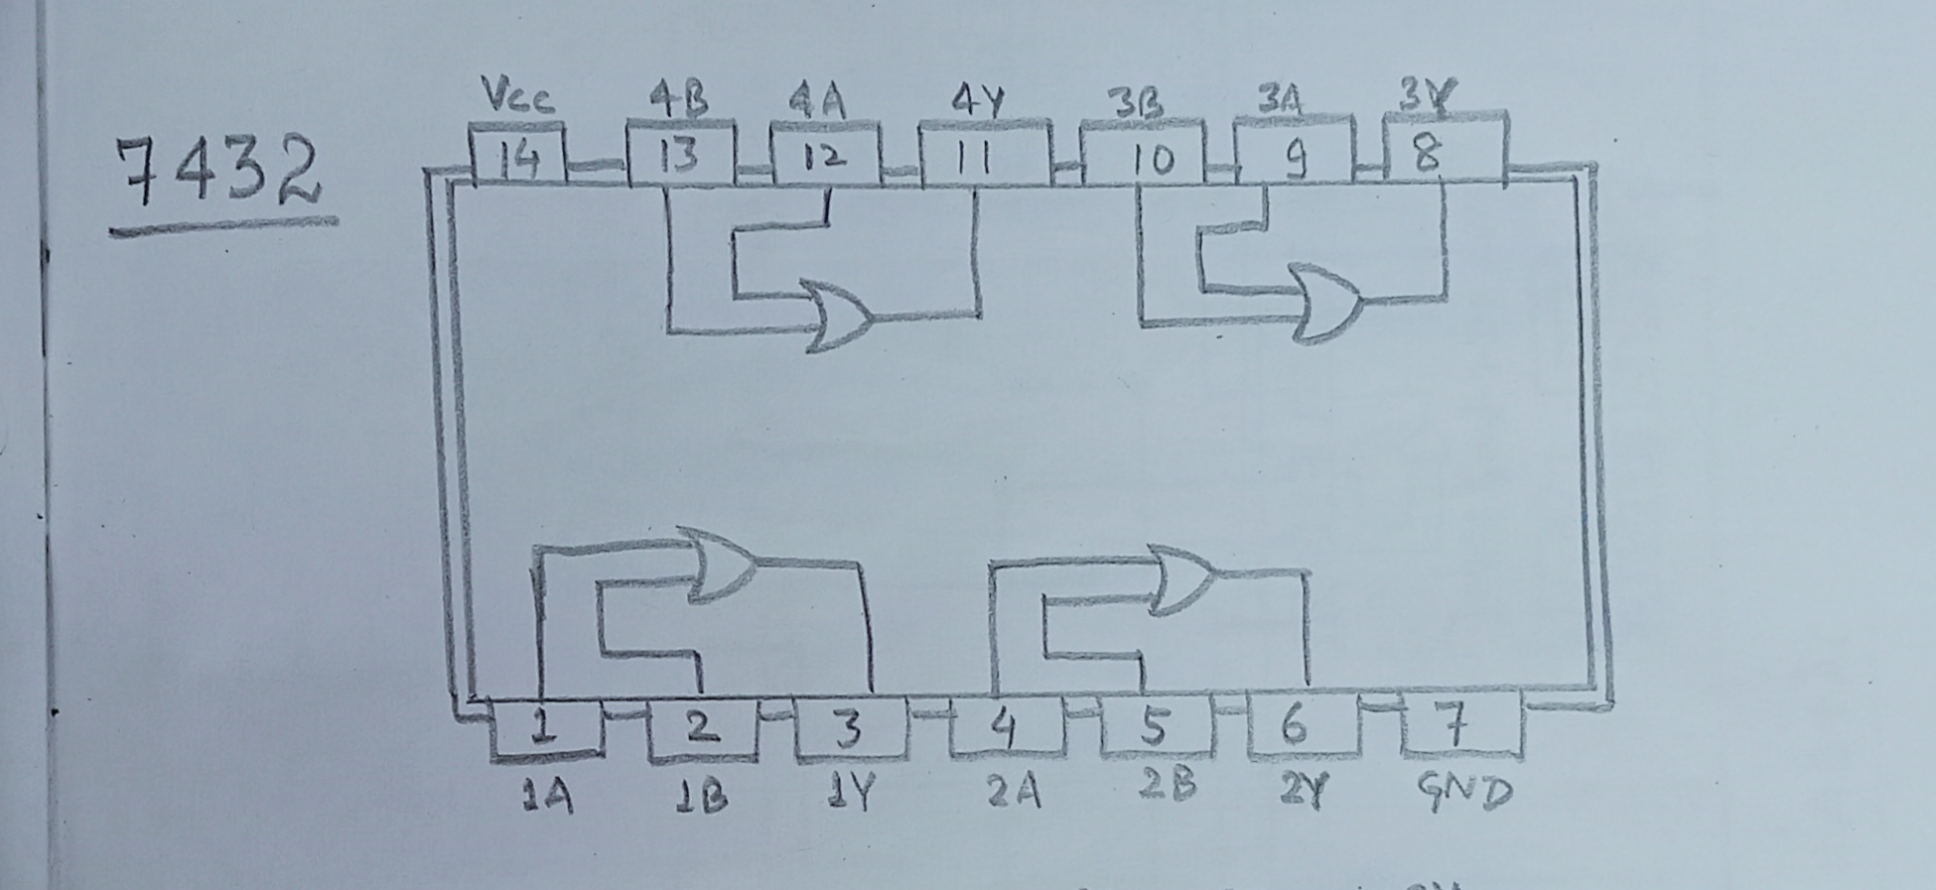

**Components:**

1. 7400(quad 2-input NAND gates)
2. 7402(quad 2-input NOR gates)
3. 7404(HEX inverter)
4. 7408(quad 2-input AND gates)
5. 7432(quad 2-input OR gates)
6. LED’s
7. Switches
8. Cells
9. Resistors
10. Connecting Wires

**Experimental Data:**

**Experiment – 1:**

**TRURTH TABLE FOR AB + A’C + BC = AB + A’C**

|  |  |  |  |  |  |  |
| --- | --- | --- | --- | --- | --- | --- |
| **A** | **B** | **C** | **AB + A’C + BC** | **ON / OFF** | **AB + A’C** | **ON / OFF** |
| **0** | **0** | **0** | **0** | **OFF** | **0** | **OFF** |
| **0** | **0** | **1** | **1** | **ON** | **1** | **ON** |
| **0** | **1** | **0** | **0** | **OFF** | **0** | **OFF** |
| **0** | **1** | **1** | **1** | **ON** | **1** | **ON** |
| **1** | **0** | **0** | **0** | **OFF** | **0** | **OFF** |
| **1** | **0** | **1** | **0** | **OFF** | **0** | **OFF** |
| **1** | **1** | **0** | **1** | **ON** | **1** | **ON** |
| **1** | **1** | **1** | **1** | **ON** | **1** | **ON** |

**LOGIC CIRCUIT OF THE ABOVE EXPRESSION -** 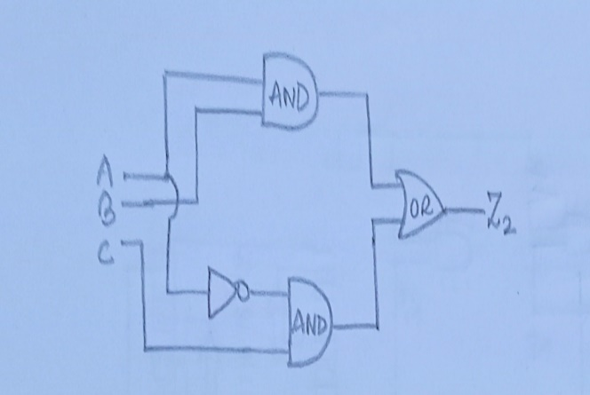 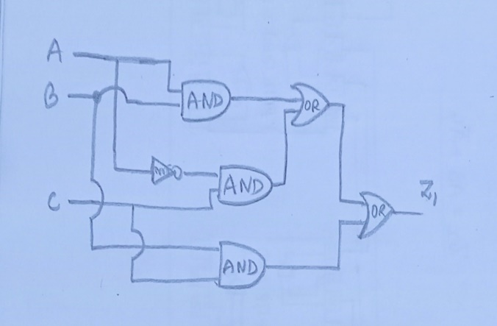

**Circuit Diagram –**

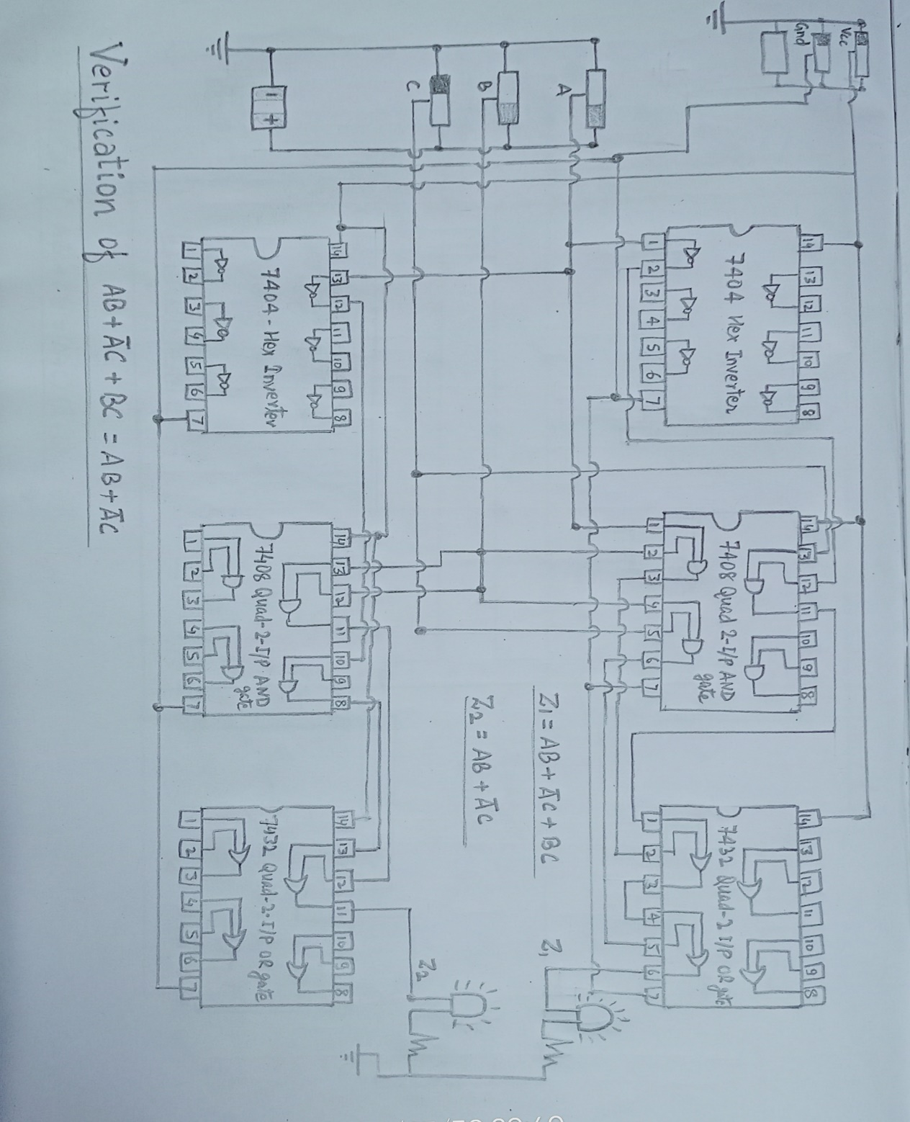

**Experiment – 2:**

**TRUTH TABLE FOR AB + A’C = (A +B )(A’ + C)**

|  |  |  |  |  |  |  |
| --- | --- | --- | --- | --- | --- | --- |
| **A** | **B** | **C** | **AB + A’C** | **ON / OFF** | **(A + B)(A’ + C)** | **ON / OFF** |
| **0** | **0** | **0** | **0** | **OFF** | **0** | **OFF** |
| **0** | **0** | **1** | **1** | **ON** | **1** | **ON** |
| **0** | **1** | **0** | **0** | **OFF** | **0** | **OFF** |
| **0** | **1** | **1** | **1** | **ON** | **1** | **ON** |
| **1** | **0** | **0** | **0** | **OFF** | **0** | **OFF** |
| **1** | **0** | **1** | **0** | **OFF** | **0** | **OFF** |
| **1** | **1** | **0** | **1** | **ON** | **1** | **ON** |
| **1** | **1** | **1** | **1** | **ON** | **1** | **ON** |

**LOGIC CIRCUIT OF THE ABOVE EXPRESSION –**

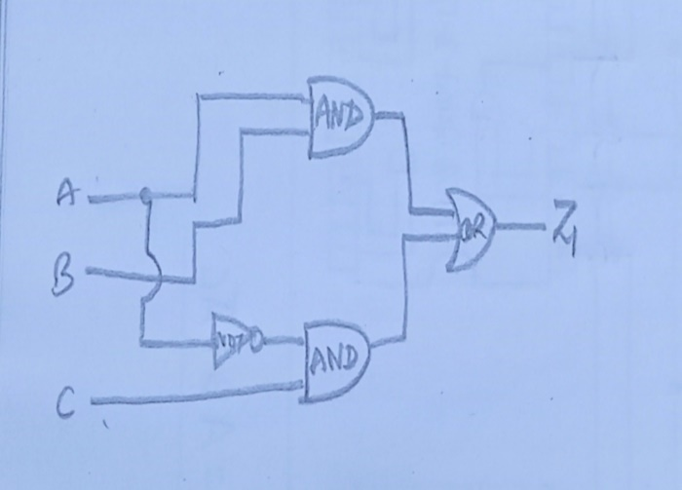 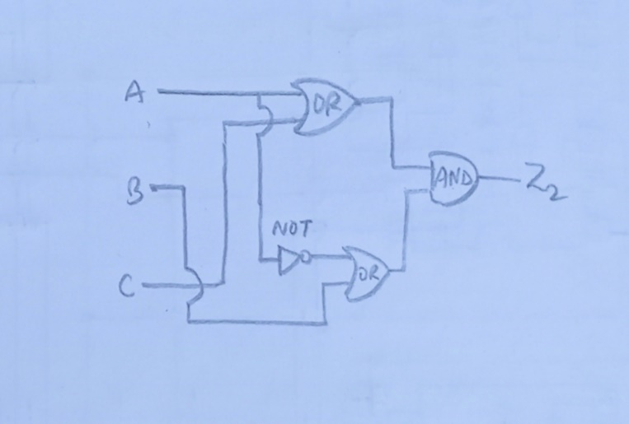

**CIRCUIT DIAGRAM –**

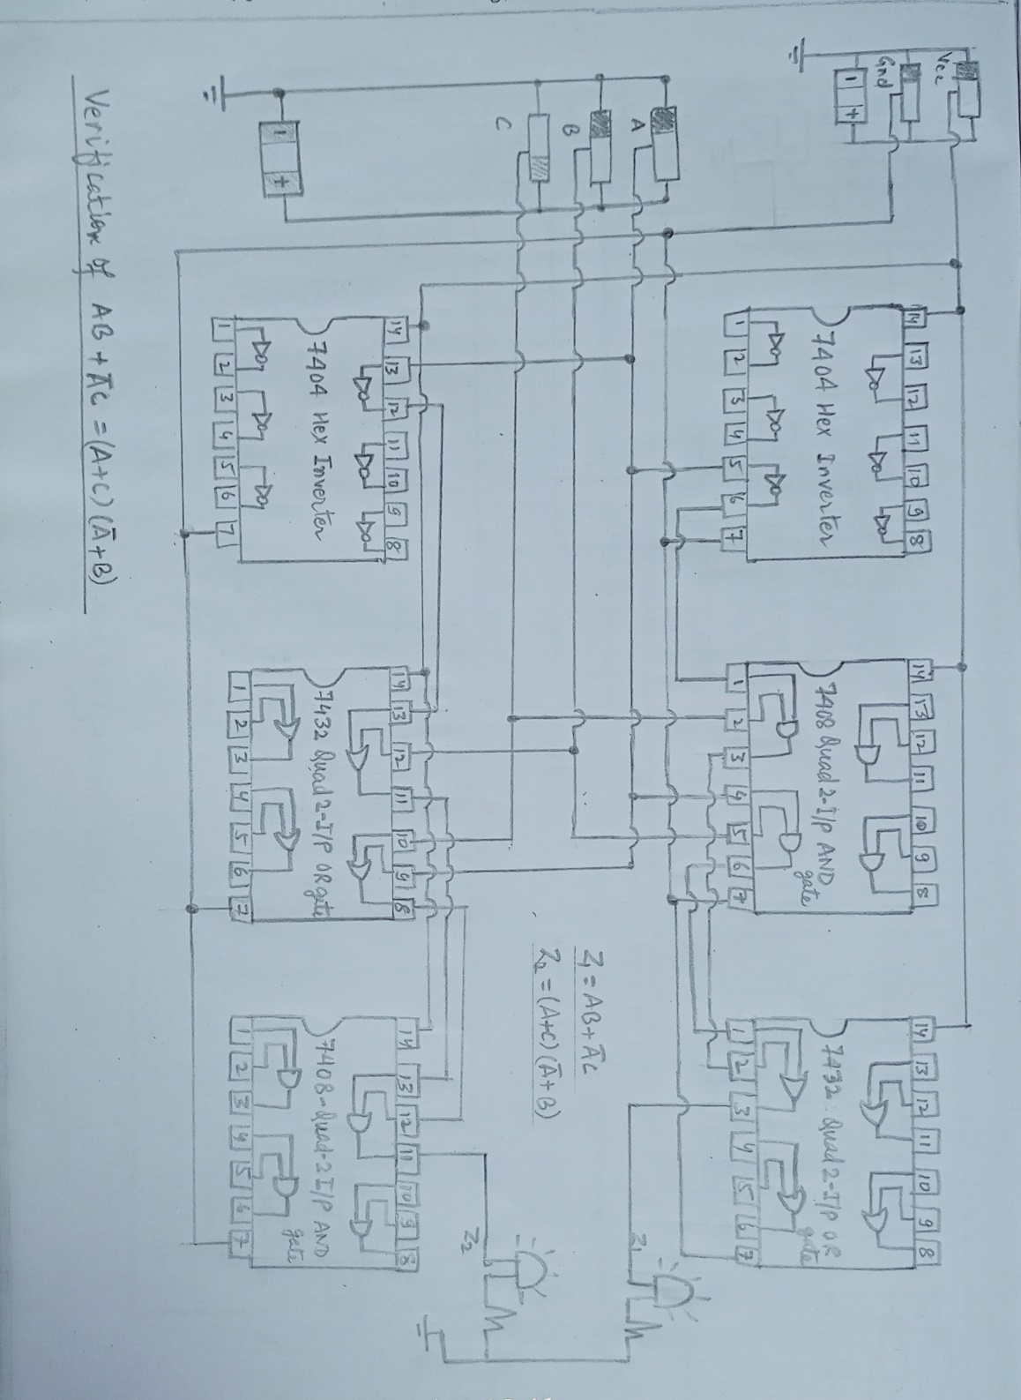

**Experiment – 3:**

**Verify the equivalence of AND-OR and NAND-NAND Structure:**

**TRUTH TABLE FOR AB + CD = (A’B ’ + C’D’)’**

|  |  |  |  |  |  |  |  |
| --- | --- | --- | --- | --- | --- | --- | --- |
|  | **B** | **C** | **D** | **AB + CD** | **ON/OFF** | **(A’B’ + C’D’)’** | **ON/OFF** |
| **0** | **0** | **0** | **0** | **0** | **OFF** | **0** | **OFF** |
| **0** | **0** | **0** | **1** | **0** | **OFF** | **0** | **OFF** |
| **0** | **0** | **1** | **0** | **0** | **OFF** | **0** | **OFF** |
| **0** | **0** | **1** | **1** | **1** | **ON** | **1** | **ON** |
| **0** | **1** | **0** | **0** | **0** | **OFF** | **0** | **OFF** |
| **0** | **1** | **0** | **1** | **0** | **OFF** | **0** | **OFF** |
| **0** | **1** | **1** | **0** | **0** | **OFF** | **0** | **OFF** |
| **0** | **1** | **1** | **1** | **1** | **ON** | **1** | **ON** |
| **1** | **0** | **0** | **0** | **0** | **OFF** | **0** | **OFF** |
| **1** | **0** | **0** | **1** | **0** | **OFF** | **0** | **OFF** |
| **1** | **0** | **1** | **0** | **0** | **OFF** | **0** | **OFF** |
| **1** | **0** | **1** | **1** | **1** | **ON** | **1** | **ON** |
| **1** | **1** | **0** | **0** | **1** | **ON** | **1** | **ON** |
| **1** | **1** | **0** | **1** | **1** | **ON** | **1** | **ON** |
| **1** | **1** | **1** | **0** | **1** | **ON** | **1** | **ON** |
| **1** | **1** | **1** | **1** | **1** | **ON** | **1** | **ON** |

**LOGIC CIRCUIT OF THE ABOVE EXPRESSION –**

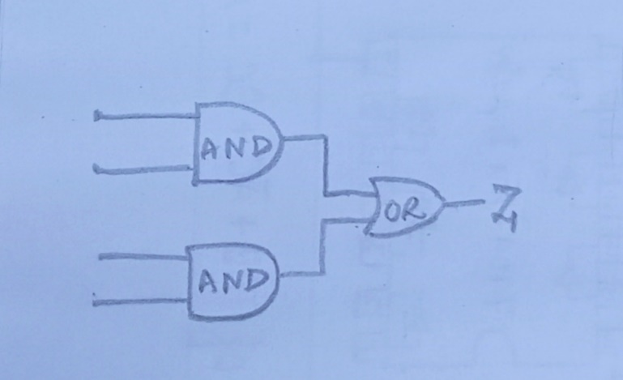 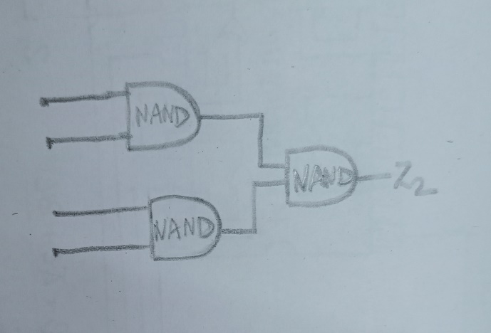

**CIRCUIT DIAGRAM –**

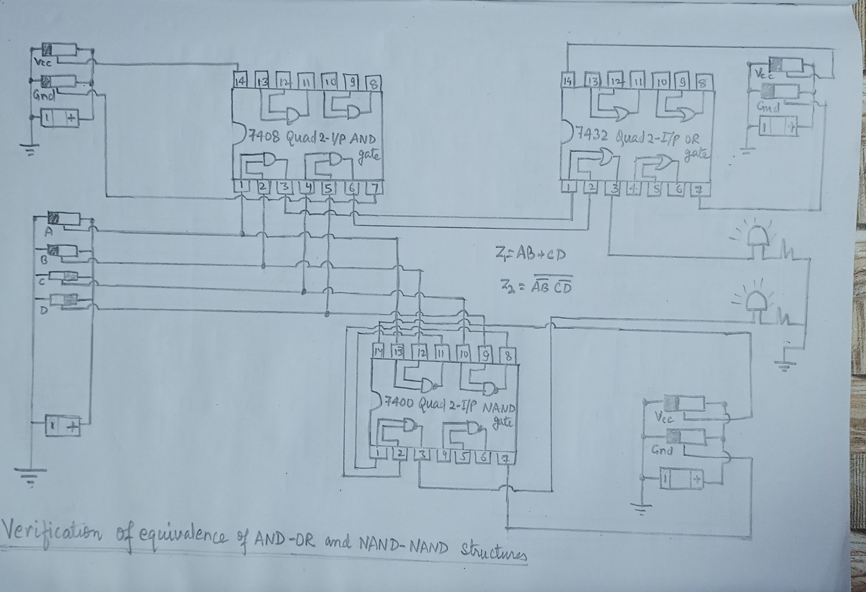

**Experiment – 4:**

**Verify the equivalence of AND-OR and NAND-NAND Structure:**

**TRUTH TABLE FOR (A + B)(C + D) = ((A’ +B ’)(C’ + D’))’**

|  |  |  |  |  |  |  |  |
| --- | --- | --- | --- | --- | --- | --- | --- |
| **A** | **B** | **C** | **D** | **(A+B) (C+D)** | **ON/OFF** | **((A’+B’)(C’+D’))’** | **ON/OFF** |
| **0** | **0** | **0** | **0** | **0** | **OFF** | **0** | **OFF** |
| **0** | **0** | **0** | **1** | **0** | **OFF** | **0** | **OFF** |
| **0** | **0** | **1** | **0** | **0** | **OFF** | **0** | **OFF** |
| **0** | **0** | **1** | **1** | **0** | **OFF** | **0** | **OFF** |
| **0** | **1** | **0** | **0** | **0** | **OFF** | **0** | **OFF** |
| **0** | **1** | **0** | **1** | **1** | **ON** | **1** | **ON** |
| **0** | **1** | **1** | **0** | **1** | **ON** | **1** | **ON** |
| **0** | **1** | **1** | **1** | **1** | **ON** | **1** | **ON** |
| **1** | **0** | **0** | **0** | **0** | **OFF** | **0** | **OFF** |
| **1** | **0** | **0** | **1** | **1** | **ON** | **1** | **ON** |
| **1** | **0** | **1** | **0** | **1** | **ON** | **1** | **ON** |
| **1** | **0** | **1** | **1** | **1** | **ON** | **1** | **ON** |
| **1** | **1** | **0** | **0** | **0** | **OFF** | **0** | **OFF** |
| **1** | **1** | **0** | **1** | **1** | **ON** | **1** | **ON** |
| **1** | **1** | **1** | **0** | **1** | **ON** | **1** | **ON** |
| **1** | **1** | **1** | **1** | **1** | **ON** | **1** | **ON** |

**LOGIC CIRCUIT OF THE ABOVE EXPRESSION –**

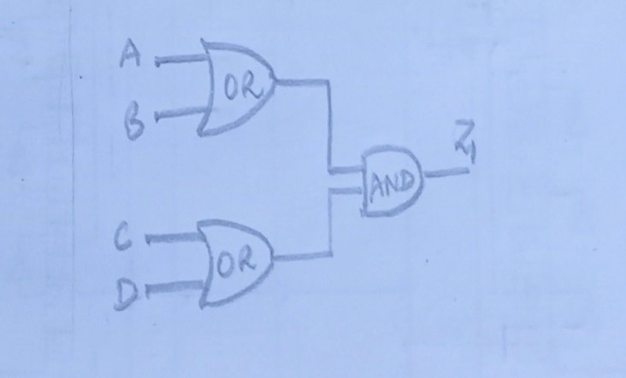 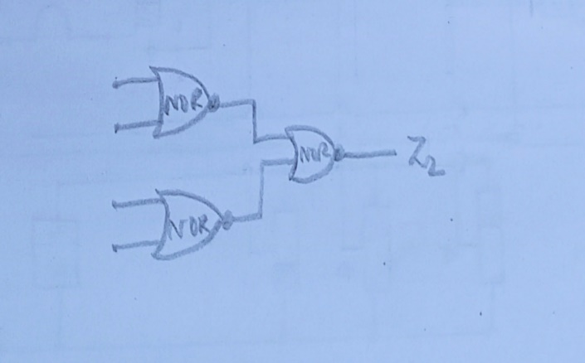

**CIRCUIT DIAGRAM –**

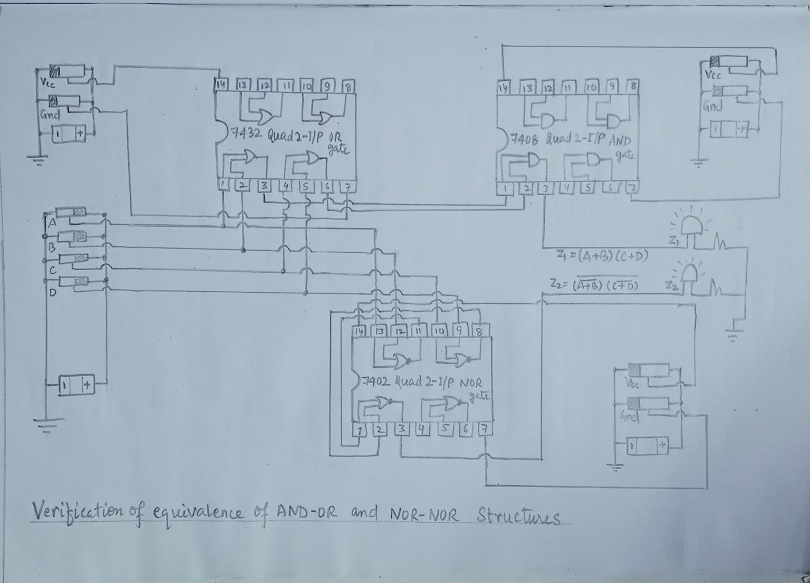

**CONCLUSION:** We understood the principal objective of this experiment with the use of logic gates 7400(quad 2-input NAND gates), 7402(quad 2-input NOR gates), 7404(Hex inverter), 7408(quad 2-input AND gates) and 7432(quad 2-input OR gates). Also, we analysed logic gates and expressed their Boolean expressions using them by checking equivalence of the Boolean expressions, also two logic circuits consisting of multiple gates.